Zoom lesson plan w/b 22nd June
Dear Parents,
As you can appreciate with the wider openings of schools, the Year 3 zoom sessions may have to change. Mrs Slate and I are in school with Year 6 and key worker children and will do our very best to continue with some zoom sessions for Year 3. Please check carefully the zoom invites for dates and times and we hope that you’re able to make them. If not, please continue using the home learning grid, work packs and the online resources to access Year 3 learning.
Kind regards
Ms McCoy and Mrs Slate.
On Tuesday 23rd at 10:00am, with Mrs Slate
There will be a maths focus. We will go through the White Rose Maths questions and look at real life situations using scales: such as baking. Children will need a pencil and paper.
On Wednesday 24th at 2:00 pm with Ms McCoy
There will be a Grammar and spellings focus. Here is the link for the suffix ous and the spelling words.
https://www.bbc.co.uk/bitesize/topics/zqqsw6f/articles/zqcpv9q
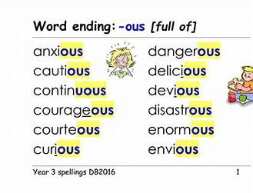
On Thursday 25th 10:00am with Mrs Slate
We will be back to our history and looking at the blitz. Try and answer the comprehension questions before the session.

Take care and we look forward to seeing you on zoom. If you have any questions or queries, do not hesitate to contact admin@broadbentfold.tameside.sch.uk

Kind regards
Ms McCoy and Mrs Slate

