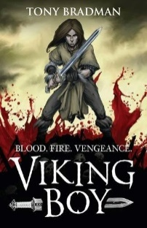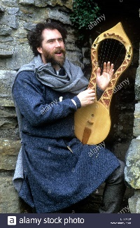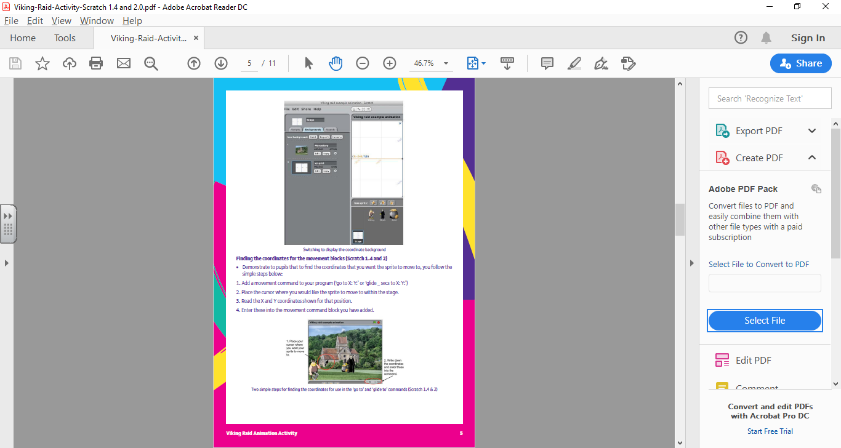

**As Religious Observers / Model Citizen we can…**

* Living in the wider world- how to be a positive member of the community
* British values: Mutual respect
* RE- What matters most to Christians and Humanists?

**As Artists/ Musicians / Designers we can…**

* Research, design and

create a Viking longship

* Look at music from

Viking times

**As Linguists we can…**

* Know the Spanish alphabet

and use adjectives

**As Readers and Writers we can…**

* Read ‘Viking Boy’- Tony Bradman
* Write newspaper reports to describe the Viking raids
* Write a dramatic Viking saga
* Link ideas across paragraphs using a wider range of cohesive devices
* Revise different word classes, Eg verb, noun, adverb, adjective

**As Computer Users we can…**

* Use ICT to create animations- use Scratch to design and debug an algorithm
* Use a 3D printer to

make a Viking

longship

**Hooks for learning:**

* Creative home learning task- make Viking artefacts/dress-up props
* Viking dress up day and saga role play- 22nd January

**As Mathematicians we can…**

* Add, subtract, multiply and divide fractions in various ways
* Explore the relationship between fractions, decimals and percentages
* Convert units of measure

**As Geographers / Historians we can…**

* Research the Viking and Anglo-Saxon struggle for the Kingdom of England to the time of Edward the Confessor

**As Scientists we can…**

* Identify and name the main parts of the human circulatory system
* Recognise the impact of diet, exercise, drugs and lifestyle
* Describe the ways in which nutrients and water are transported within animals

**As Sports People we can…**

* Hockey skills- Sports coach
* Viking dances

**Were the Vikings vicious or victorious?**