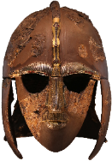
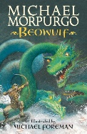
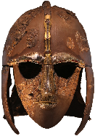
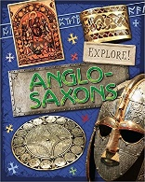
As Religious Observers / Model Citizens we can …
- Explore our PSHE theme of Relationships and how to recognise bullying and abuse, both in person and online.
- In RE, explore the question, “If God is everywhere, why go to a place of worship?” Discuss different religions.
As Mathematicians we can…
- Explore Decimals and Percentages, Perimeter and Area and Statistics.
- Study Shape, including Angles, Polygons and 3-D shapes.
As Scientists we can explore Materials and their Properties and be able to….
- Compare and group materials based on their properties.
- Know and explain how a material dissolves to form a solution and demonstrate how some materials can be separated.
- Know and demonstrate that some changes are reversible, and some are not.

Reading Text Links are…
- Beowulf (Fiction) by Michael Morpurgo
- Explore Anglo Saxons (Non-fiction) by Jane Bingham.
As Sports People we can:
- Cooperate, communicate and collaborate in Football sessions.
- Develop skills for playing Rounders including throwing, catching and fielding
As Artists / Musicians / Designers we can…
- Research The Bayeux Tapestry and design a new section to represent Anglo Saxon life.
- Design and make an Anglo Saxon shield or Helmet to use on Anglo Saxon Day (Creative homework task.)
- Design and make Anglo Saxon jewellery using different materials.
- Develop musical skills and language using our new Music scheme, “Sing Up”.
As Computer Users we can…
- Create a video using filming techniques, planning and production
- Focus on Internet Safety.
- Recognise acceptable and unacceptable behaviour in technology in the context of Internet Safety.
As Readers and Writers we can…
- Improve vocabulary using Vocabulary Ninja.
- Learn how to include parenthesis and recap the use of semi-colons to create interest in writing.
- Write Non-chronological reports based on aspects of Anglo Saxon life.
- Read and evaluate Michael Morpurgo’s “Beowulf” and relate it to early poetry.
- Look at Poetry in the form of Anglo Saxon Kennings and Riddles.

As Historians/Geographers we can:
- Know how Britain changed between the end of the Roman occupation and 1066.
- Explore how the Anglo-Saxons attempted to bring about law and order into the country.
- Learn that during the Anglo-Saxon period Britain was divided into many kingdoms which led to the creation of some of our county boundaries today
- Use a timeline to show the Anglo-Saxon period.
Hooks for learning:
- Engage in an Anglo Saxon Day at school (weaving, baking, etc)
- Children become detectives to investigate the Sutton Hoo bodiless ship burial
Who were the Anglo Saxons?

