Topic | The Americas  Happy New Year! It is such a shame that we can't welcome you back to school after the Christmas holidays but I hope that you’re all keeping well and will engage in the work that I’m preparing. It’s really important that all the fantastic learning that you did in the Autumn Term isn’t lost.  Please place any work on Seesaw and I look forward to seeing you all on zoom. If you have any issues, questions or concerns do not hesitate to contact admin@broadbentfold.tameside.sch.uk  Take good care  Ms McCoy
Literacy and Communication | https://www.bbc.co.uk/bitesize/topics/zhrrd2p  Please continue to use the bitesize link to practice your spellings, punctuation and grammar.  This week, focus on how to use a relative clauses, subordinating and coordinating conjunctions. Make sure you use these in your writing pieces.
https://classroom.thenational.academy/lessons/to-explore-the-four-types-of-sentence-statement-command-exclamation-and-question-c9jked
Use this Oak Academy video to practise spellings and statements, commands, questions and exclamations.

News reports- Write a newspaper report about the current situation about schools being shut and the country being in lockdown again.
Use the guidance below to guide your report and write it up on the sheet. Don’t forget to post these on Seesaw.
We will share these on Friday morning zoom session
 | Headline | Orientation  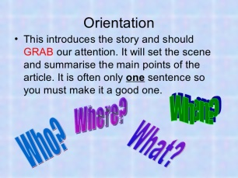 | Main Body  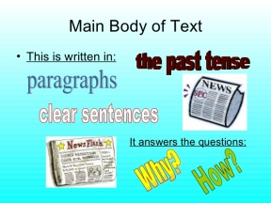 | Eye Witness account  Remember how to use speech marks accurately.
Maths and Problem Solving | White Rose Maths- Short Multiplication Practise. Use the Power Points and worksheets to practise short multiplication.
Use this link as a guide to short multiplication
https://classroom.thenational.academy/lessons/use-formal-written-methods-for-short-multiplication-including-multiplying-decimals-6rvp2r
We will go through these on Wednesday and Thursday morning zoom session
Check out the resources, activities and lessons set on MyMaths.
School login: broadbent
School password: boostbroadbent
Science and the outside environment | Use the bitesize resources to find out about food chains. Create a food web that includes species in different habitats. Try and include at least 5 producers and 12 consumers of which 4 are herbivores, 4 are omnivores and 4 are carnivores.  https://www.bbc.co.uk/bitesize/topics/zbnnb9q  https://www.youtube.com/watch?v=hLq2datPo5M  We will share these on Wednesday afternoon zoom session
Humanities and Citizenship | Watch Newsround and stay up to date with the latest news for children. If you have any questions about Newsround, please ask an adult. https://www.bbc.co.uk/newsround/news/watch_newsround.  Mapping Skills- follow this lesson plan and sheet to identify countries and states in America. Don’t forget to post your maps on Seesaw.  Have a go at this quiz  US States Map Quiz (sporcle.com)  We will share these on Thursday afternoon zoom session
Creative Arts | 11 UNIQUE IDEAS FOR KIDS' ART PROJECTS - Bing video  Watch this video and create at least one of the craft activities. Don’t forget to post pictures of your activities on Seesaw.  We will share these on Friday afternoon zoom session
Physical Education | Dance, move and exercise.  It is so important to be outside, take a walk with your family or play in your garden.  Here are some other ideas to keep healthy:  - 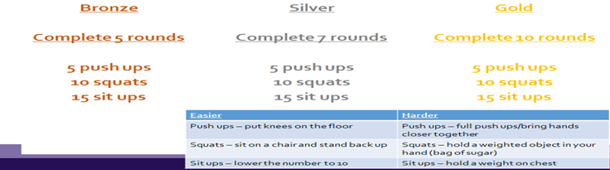  It’s time to follow the challenge grid! Can you complete the Bronze, Silver or Gold challenge this week. If you’re going for bronze then complete the exercises 5 times in the week- silver is 7 times in the week or are you fit? If so, complete the gold routine. Check your heartbeat and record what it is before and after exercise.
Reading | Reading- aim for 30 minutes a day  - Internet research on The Americas.  - Read your favourite stories.  - Put subtitles on the TV and read as you watch TV.  - https://classroom.thenational.academy/lessons/to-develop-reading-for-pleasure-through-book-recommendations-c5jp6r |  | Try and keep a list of the books you read, we could see who reads the most.  - Use the new EPIC link and complete some reading quizzes.  https://www.getepic.com/app/profile-select  Class Code: ieb2643
Times tables | Do not forget to continue to practise your timetables. Spend 10 minutes a day at least on TT Rockstars. https://ttrockstars.com/  Year 5 children need to know all their times tables.  If you’re at the stage for a test- use this link to help test your knowledge.  http://www.timestables.me.uk/

