Dear Parents, Carers
I do hope that you are all keeping safe and staying well. Please find attached the home learning for the week beginning 16th November. If your child completes any work, please post it on Seesaw, where I aim to review it daily. Further zoom links will be sent to you via School Ping on a daily basis.
If you have any issues, worries or concerns, do not hesitate to contact admin@broadbentfold.tameside.sch.uk

Kind regards
Ms McCoy.
Literacy and Communication | https://www.bbc.co.uk/bitesize/topics/zvwwxnb/articles/zcyv4qt  Please continue to use the bitesize link to practice your spellings, punctuation and grammar.  This week focus on how to use an apostrophe in a contraction. We will be going through this on Monday’s zoom session.
Chapter 3 Kensuke’s Kingdom.
Last week we found out that Michael went over the side of Peggy Sue. Create a Missing Person’s poster that his parents may hand to the police/ put up or show around so that they can get Michael safety back home. You can represent your information in any way you wish. See the examples below:
We will show these posters in Tuesday’s zoom session
 | 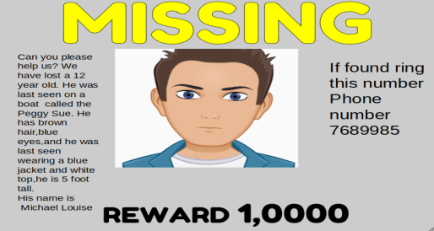 | 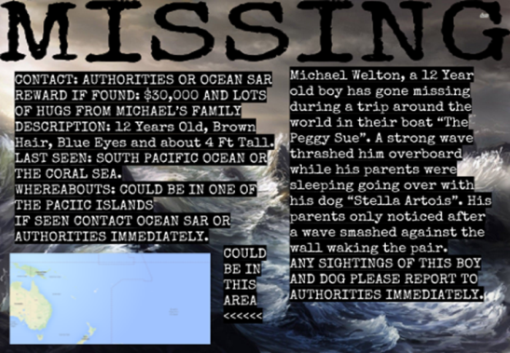
Michael Morpurgo Research
Find out about Michael Morpurgo. Read the attachment and follow the links, and watch some of these videos. Write about Michael Morpurgo.
https://www.youtube.com/watch?v=-MV9WqzT3TM
https://www.youtube.com/watch?v=pijeynanwRo
https://www.youtube.com/watch?v=QzAJ3oxYdy4
We will be answering some questions about Michael Morpurgo in Wednesday’s zoom session.

Maths and Problem Solving | It’s practise time:  Use the attached website to practise for at least 30 minutes a day. See if you can win the Maths World Cup!  http://www.math-exercises-for-kids.com/learning-math-8.htm
Maths with Carol Vorderman: https://www.themathsfactor.com/.
Click join free today. You will need an adult to help you set this up.
Here is a link for Maths activities for the scheme that we use in school - White Rose Maths. The children are familiar with this scheme and therefore we recommend that you access this link to enhance your child's learning at home. https://whiterosemaths.com/homelearning/

Do not forget to continue to practise your timetables. Spend 10 minutes a day at least on TT Rockstars. https://ttrockstars.com/
Year 5 children need to know all their times tables.

If you’re at the stage for a test- use this link to help test your knowledge.

http://www.timestables.me.uk/

We will be doing some maths in our Thursday’s zoom session.
Topic | Anti- Bullying Week  Watch some of the Anti-bullying videos https://www.bing.com/videos/search?q=anti+bullying+week+2020&FORM=HDRSC4  Follow the link to create a Chatterbox- in each section, write a positive anti- bullying message.  We will show these in Friday’s zoom session.  How to make a chatterbox  https://www.bing.com/videos/search?q=art-+how+to+makechatterboxes&docid=608037738804021563&mid=C81FF3C2EE33A715EDBCC81FF3C2EE33A715EDBC&view=detail&FORM=VIRE  Anti- bullying positive quotes  https://www.bing.com/images/search?q=anti%20bullying%20positive%20%20quotes&qs=n&form=QBIR&sp=-1&pq=anti%20bullying%20positive%20quotes&sc=2-29&cvid=B1CFF6E7805849EB9D566DEF66798645&first=1&scenario=ImageBasicHover
Humanities and Citizenship | Watch Newsround and stay up to date with the latest news for children. If you have any questions about Newsround, please ask an adult. https://www.bbc.co.uk/newsround/news/watch_newsround.  Try out this geography scavenger hunt too: https://digimapforschools.edina.ac.uk/resources/scavengerhunt/
Physical Education | Dance, move and exercise.  It is so important to be active, even when you’re in the house so make sure you get chance to play in your garden. |  | Other skills:  - Throw and catch (against a wall or to a partner)  - Football skills  - Skipping
Reading | Reading- aim for 30 minutes a day  - Use the new EPIC link and complete some reading quizzes.  https://www.getepic.com/app/profile-select  Class Code: ieb2643 |  | Try and keep a list of the books you read, we could see who reads the most. Try and read a different Michael Morpurgo book.

