Topic | Here are some ideas for you to complete at home whilst you are self-isolating this week.  World War 2
Literacy and Communication  History and Art/ D&T  Grammar | Theme: World War 2- The Role of Women  Use the video and research about the role of women during WW2.  https://www.bing.com/videos/search?q=role+of+women+in+ww2+video+for+kids&&view=detail&mid=24967782772FD0D6439224967782772FD0D64392&&FORM=VRDGAR&ru=%2Fvideos%2Fsearch%3Fq%3Drole%2520of%2520women%2520in%2520ww2%2520video%2520for%2520kids%26qs%3Dn%26form%3DQBVR%26sp%3D-1%26pq%3Drole%2520of%2520women%2520in%2520ww2%2520video%2520for%2520kids%26sc%3D0-35%26sk%3D%26cvid%3DA00714FC13554F21B98CD61AA17FDD32  Create your own propaganda poster advertising jobs for women.  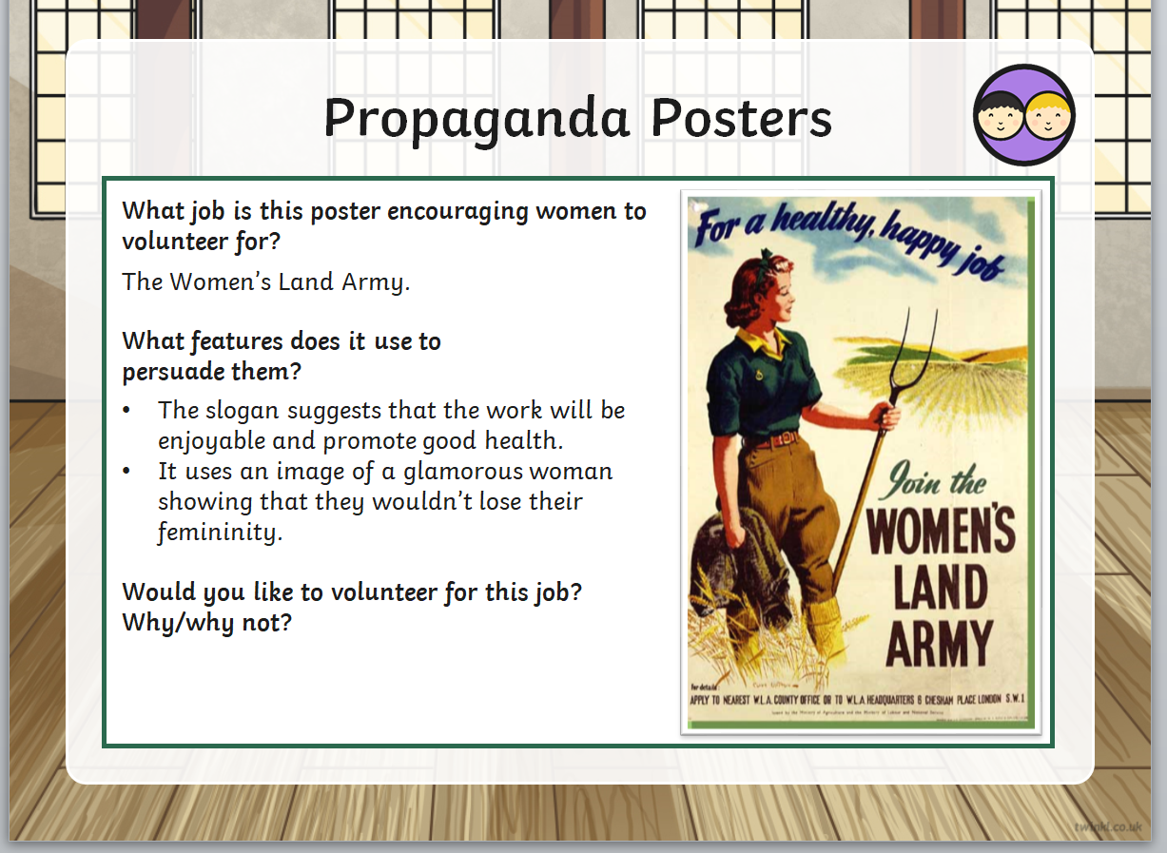
https://www.bbc.co.uk/bitesize/topics/zhrrd2p

https://www.bbc.co.uk/bitesize/topics/zvwwxnb/articles/zx9ydxs
Please start to use the bitesize link to practice your spellings, punctuation and grammar.
This week, focus on how to use an apostrophe in possession.
Science and the outside environment | Our topic is Light. Find out how you shadows and how they’re created.  https://www.bbc.co.uk/bitesize/clips/z87jmp3  Use the video to help you create a puppet that has transparent, translucent and opaque materials used. Use the guidance to help you plan.
Maths and Problem Solving | Each lesson listed below has a teacher led video clip on https://whiterosemaths.com/homelearning/year-3/ (ignore the date on the link)  - Watch video links (watch one at a time)  - Complete worksheets (see blog attachments)  Lesson 1 - Right angles in shapes  Lesson 2 - Compare angles  Lesson 3 - Horizontal and vertical  Lesson 4 - Parallel & perpendicular lines
Religious Education | Tuesday 7th July RE lesson on Zoom (worksheet attached to complete after the lesson)  Additional RE – Judaism –how does the beliefs of a Jew differ/ or is the same as your own beliefs  https://www.bbc.co.uk/bitesize/topics/znwhfg8  Make a Hannukah card. Share it with us on Seesaw.  A Christian has a special book called the Bible, what items are special to a person who is a Jew?
Physical Education | https://www.bbc.co.uk/teach/class-clips-video/physical-education-ks1-ks2-lets-get-active/z72yjhv  How about smile and do a mile! (run, jog or walk)  Active Tameside are doing PE lessons online check out their website  https://www.activetameside.com/bhangra-dance-pe-dance-lesson-with-lianne/ | We have enjoyed seeing all the children sending in The Tour of Tameside photos, dribbling, running and walking.  Keep up your exercise
Reading | Daily read in a variety of ways:  - Continue with Tom Palmer,The Spitfire Fund. Here are links to the rest of the chapters https://www.rafmuseum.org.uk/london/schools/resources.aspx  - Read and answer bug club questions- we will move children on to higher level books once they have shown good understanding  - Listen to audiobooks online  - Have you shared a story with your sibling or video yourself reading a story and say it with a friend (remember your e-safety and make sure an adult knows that you are sharing videos) |  | Write a review of The Spitfire  Maybe you could send it off to Tom Palmer, I sure he would appreciate it.
Times tables | Timestables rockstars, keep it up  Mymaths and education city – well done Year 3 for completing the games online.  If you’re at the stage for a test- use this link to help test your knowledge.  http://www.timestables.me.uk/
Spanish | https://classroom.thenational.academy/subjects-by-year/year-3/subjects/foundation scroll down until you see Spanish-there are several lessons on here, children should be able to watch and learn independently.  Or Use this website to learn about the Spanish vocabulary on classroom objects  https://www.spanishkidstuff.com/worksheets/school-classroom-objects.html

Here are the details for a new handwriting scheme that can be used at home:
Home-School Account
User name: |  | jk5800
Account Password: |  | home

Tablet Edition
User name: |  | jk5800
Swipe code: |  | A capital 'L' shape starting at top left

Thank you parents and Year 3 children for sharing home school learning with us.
Keep reading our blog updates.
Keep safe.

