Worry dolls

The indigenous people from the Highlands in Guatemala created Worry Dolls many generations ago as a remedy for worrying. According to the Mayan legend, when worrying keeps a person awake, he or she tells a worry to as many dolls as necessary. Then the worrier places the dolls under his or her pillow. The dolls take over the worrying for the person who then sleeps peacefully through the night. When morning breaks, the person awakens without the worries that the dolls took away during the night.
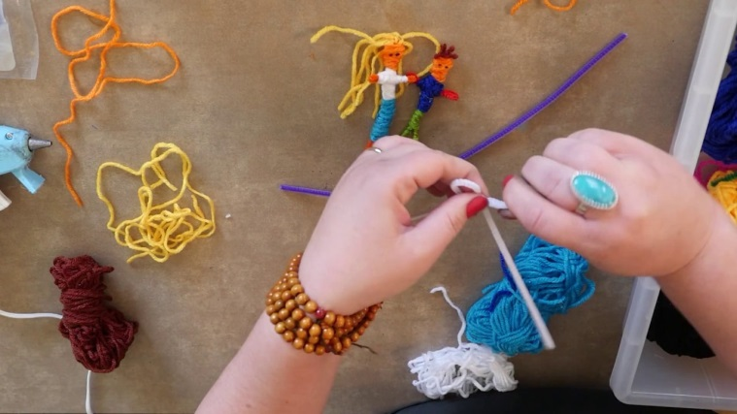
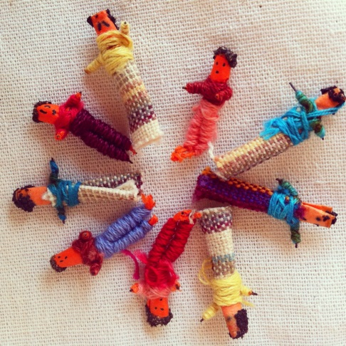

Watch this Youtube clip for instructions: https://www.youtube.com/watch?v=JJWmReMZSAA

Please send us in pictures of your final products!

