What is in blood?

What you will need:
- Newspaper to cover an area
- Plastic protective gloves
- Small plastic bottles
- 1 Measuring jug
- Pipettes/funnel (optional)
- Water for each bottle to be 2/3 full
- yellow and food colouring
- a pinch of salt
- small white marshmallows
- small purple pompoms to represent platelets
- cheerio type cereals
- 1 Large strong zip plastic bag

Step 1.
Firstly make the plasma- fill the plastic bottle approximately ¾ full. Place 6 drops of yellow food colouring into the bottle of water. Add a pinch of salt to show the minerals that are present.

Step 2.
Then add the red blood cells- add the cheerio type cereal. Put into a large plastic zip type bag and add a whole bottle of red food colouring-use gloves.
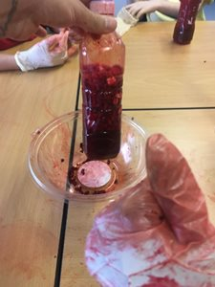
Step 3.
Ensure the cereal is covered in red food colouring by shaking the bag-ensuring it is tightly closed-gloves are a must here! Add about 20 mini white marshmallows to act as the white blood cells.

Step 4.
Next put 6-8 small purple pompoms into the plastic bottle. You now have a bottle of blood!

