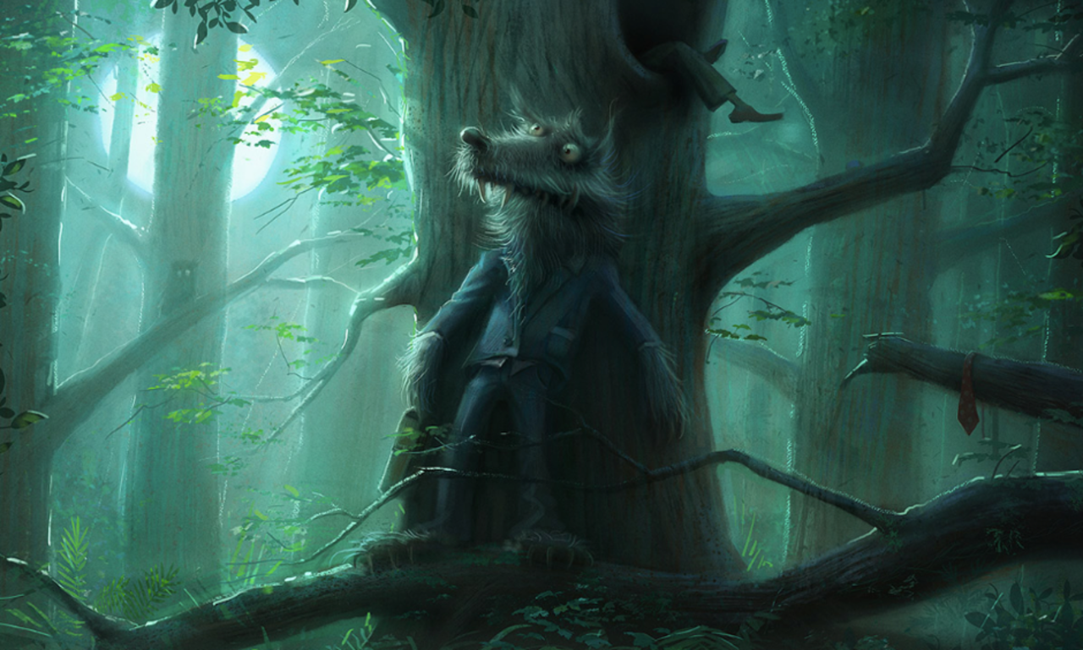In the deepest, darkest depths of the forest, Mr. Wolf waited.
His disguise hadn’t worked, but that didn’t concern him. Now, the boy thought he was safe. Mr. Wolf didn’t think he was. Mr. Wolf knew exactly where he was. He could sense him. He could smell him. He could almost taste him…
Can you continue the story about the wolf?

