“Bert strides down the path in the sunshine. He turns back at the gate – and just look at him. There’s a big grin on Bert’s face. Angelino is waving, all by himself.”
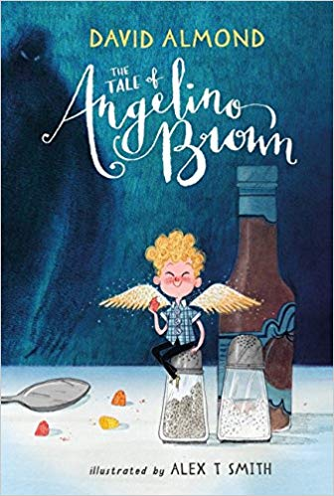
If Angelino could talk, what do you think he would say to Bert in this moment? What would he be thinking? Think about what you have read so far to complete the thought and speech bubbles.

