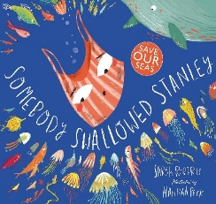
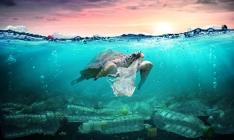
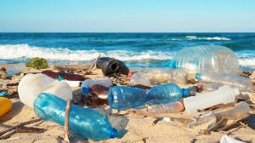
Hooks for learning
- Make puppets-for Punch & Judy show
- Sports’ week
- Litter picking!
- Artist who have created work from recycled materials

As Religious Observers / Model Citizen we can recognise:
*How should we care for others and the world around us?
*Why does it matter that we care for others and the world around us?
*How do different religions do this?
As Model Citizen through P.S.H.E we can recognise:
*That we grow older and know how to keep safe for example in the sun, and in different environments.
*Name body parts.
*How to keep safe, recognise risks at home and in the environment and know what to do in an emergency.
.
As Computer Users we can…
*Exploring coding skills to create a seaside inspired art using Scratch Jr.

As Readers and Writers we can…
- Reading gems based on class texts
- Write a cohesive story after orally rehearsing.
- Read and write information leaflet.
- Read and write diamante poems
- Use conjunctions to expand sentence types (and, but, because, when, that, if and so).
- Spell Year 2 common exception words.
- Using prefixes and suffixes spelt correctly in sentences.
As Scientists we can…
*Explore and compare the differences between things that are living, dead, and things that have never been alive.
* Identify that most living things live in habitats to which they are suited and describe how different habitats provide for the basic needs of different kinds of animals and plants.
*Identify and name a variety of plants and animals in their habitats, including microhabitats.
*Describe how animals obtain their food from plants and other animals, using the idea of a simple food chain.
Reading Text Links are…
*Somebody swallowed Stanley
*Somebody crunched Colin
*Non-fiction texts: seaside/the sea/
pollution/plastic.

How can we save our oceans?

As Geographers / Historian we can…
*Comparing the British seaside in the 1900’s (Victorian era) with modern British holidays.
*Learn about different places people visit abroad for their holidays.
*Understand physical features of mountains, lakes, forests, valleys, rivers and beaches.
*Discover why David Attenborough is a significant person in history.

As Artists/ Musicians / Designers we can…
*Learn how to sew a running stitch ready to design, make and decorate a puppet.
*Designing -Think of an idea and plan what to do next and explain why they have chosen specific textiles
*Join materials and components in different ways, measure materials to use in model or structure

*Create art work using recycled materials -look at how artist have used colours, patterns and shapes.
*Look at famous seascape artist J>M. W Turner
*Blend and mix colours to create new colours to create a seaside scene
As Mathematicians we can…
- Telling the time
- Geometry, position and direction
- Statistics
- Problem solving & Reasoning
- Know times tables X2 X5 X10 X4

As Sports People we can…
*In Athletics develop fundamental movement skills to become increasingly competent and confident in basic movements including running, jumping, throwing, and catching.
*Develop our balance, co-ordination and agility (ABC’s).
*Through Striking and Fielding apply ABC’s into an athletics and modified bat and ball sports such as Tennis, quick-cricket and rounders.
*Develop simple tactics in games.

