Year 2 Home Learning Challenge Grid Broadbent Fold Primary School and Nursery
When you are out and about look for- physical features e.g. rivers, mountains,  lakes, forests, beaches and valleys. (Photograph them) | Mathletics- complete 6 activities | Can you cut up food into halves,  quarters and thirds and show  your fractions?  ½, 1/3, ¼, ¾. | Build a waterproof shelter in your garden/in the local community  and go on a nature walk.  Or take photos of wild life and plants. How many can you name? | Addition and subtractions using 2-digit numbers using the column method.
Do you own writing- a story, a poem or a non-chronological report/fact file. | 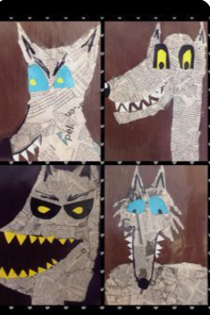  Produce a piece of art with based on the wolf. |  | Can you get active? Show or write different ways to keep  fit and healthy. | Explain how you care for others,, why it matters and how it helps the  world.  Do you help your neighbours?  Do you look after your pets?  Or tidy your bedroom?
You can also complete any of the activities into your homework book which will be collected in the last week of each half term. |  | Can you create a picture using natural materials in the style of Andy Goldsworthy? | Reading – read 5 times a week.  Parents please tick here if children do this. | 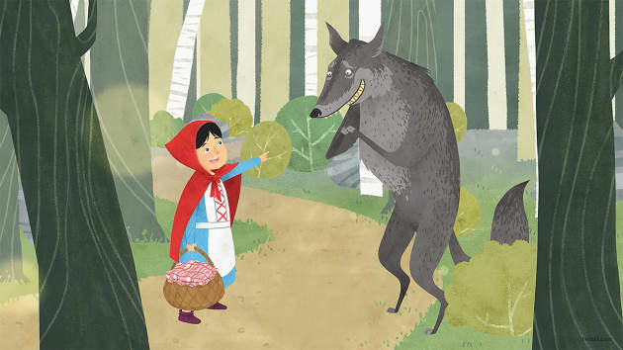
Summer term 1 Who’s afraid of the Big Bad WOLF?
Complete 8: Gold Award, 6: Silver Award, 4: Bronze Award

