Stop Deforestation!!
Deforestation is the clearing or thinning of rainforests and jungles by humans. It is one of the largest issues in global land use. A lot of habitats get destroyed which leads to a lot of animals becoming ill, cold and getting viruses.

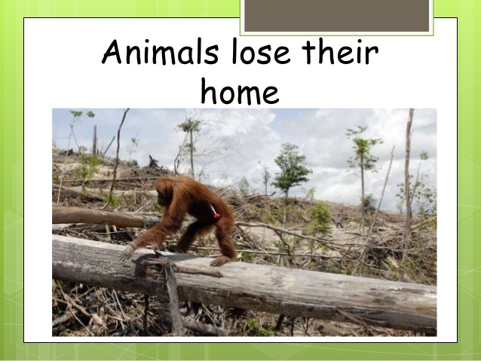

HOW CAN WE HELP
*we can help by making new homes for the animals.
* Putting up posters knowing they are in danger.

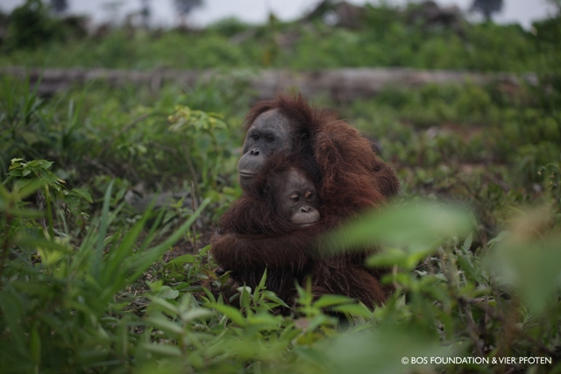
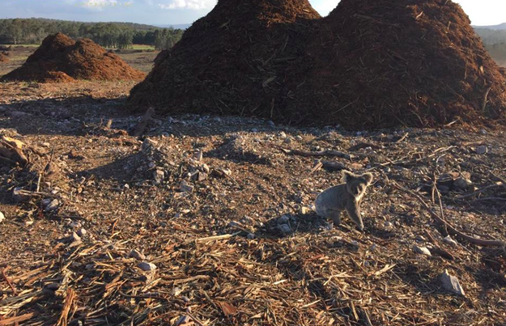

Facts about deforestation
*An equivalent of 36 football pitches worth of trees are lost every minute because of deforestation.
*31000 square miles of tropical forests are being destroyed every year.
*In the last 60 years nearly half of the world’s rainforests are lost.
*Indonesia has the most deforestation in the world. It lost 15 million acres of forests between 2000 -2012.
*In 2015 6000 square kilometres of forest were lost in the Brazilian Amazon. They were used to build ranches, roads and farm land.
We can help by planting new trees on deforested lands to protect our climate for future generations and protect our animals and wild life.

By Coban and Kasia Taylor

