Christmas Around the World by Phoebe Easter

Australia

Australia is the smallest continent and one of the largest countries on earth, lying between the Pacific and Indian oceans in the southern hemisphere. Australia’s capital city is Canberra located in the southeast between the larger and more important economic and cultural centres of Sydney and Melbourne.

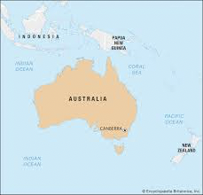

Australia’s language is, English. However, there are other languages spoken and the top 5 are:
- English
- Mandarin
- Arabic
- Cantonese
- Vietnamese

Highest mountain in Australia

Mount Kosciuszko is Australia’s tallest mountain it is 2228 metres above sea level. It is loacated on the Main Range of the Snowy Mountains in Kosciuszko National Park in New South Wales, Australia.

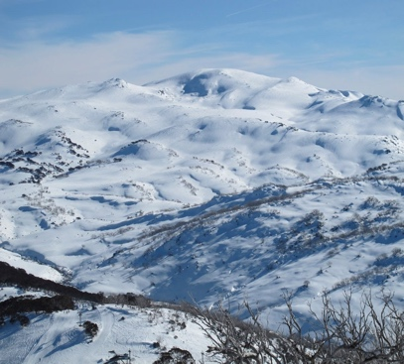

Longest river in Australia

Australia’s longest river is called, River Murray. It is 2508 kilometres long.
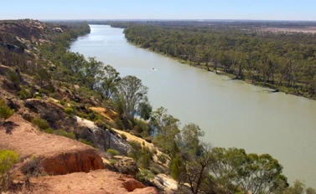

Australia’s Christmas traditions

- Surfing Santa – Traditional Santas wear bright red fleeces suits lined with white fur and big black boots to fight off the northern winter
- Eating prawns
- Street parties
- Boxing Day BBQs
- Carols by candlelight
- Christmas lunch
