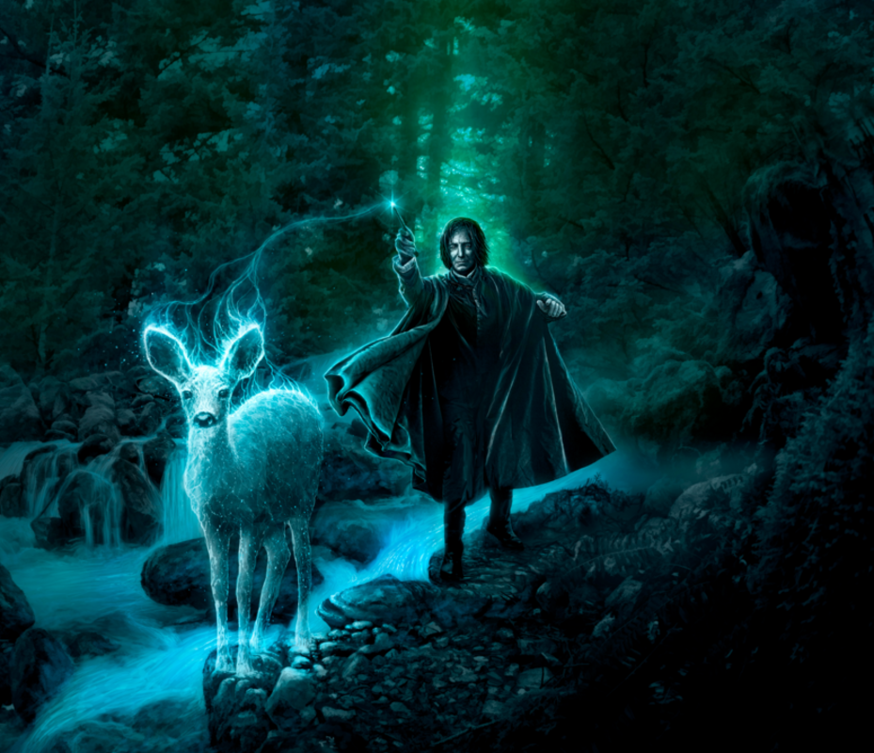

The Patronus Charm is difficult to produce, and many witches and wizards struggle to produce a full Patronus: a guardian which generally takes the form of the animal with whom they share the deepest affinity. For Severus Snape however, a wizard trained and experienced in the Dark Arts, it was easy.
He felt a slight tingle from the end of his wand as he swished it in a smooth, subtle arc. A jet of flawless, pale-white light danced from its tip, and the Patronus began to take form in front of him…
- What form does Severus Snape’s Patronus take?
- Why do you think the Patronus charm is a particularly difficult spell to cast?
- Why has Snape performed the charm?
- Where do you think Professor Snape is?
- What might be about to happen?
- Is anyone else in the Forbidden Forest with him?
- Do you know of any other creatures that dwell there?
- Do you know what form Harry Potter’s Patronus takes?

Sentence challenge!
Can you identify all of the verbs in the following sentences?
Professor Snape flicked his wand and a stream of bright light shone into the night. A bright, white doe appeared in front of him. He smiled as the doe danced across the forest, but began to frown when he saw the Dementor approaching.

Perfect picture!
Can you draw your favourite character from Harry Potter performing a spell?

