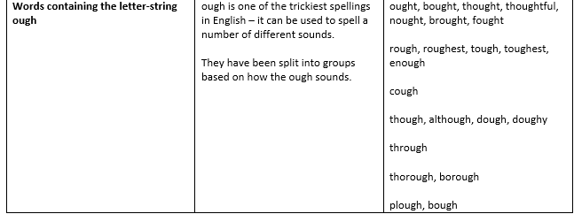
- Knead the_________________ to make the pizza.
- Even ____________ he was tired, he kept running.
- __________________ I'm sick, I'll still go to work.
- He kicked the ball _______________ the window.
- The main branch of tree is called a _________.
- The farmer used a ______________ in his field.
- The path was_______________ and rocky.
- This meat is far too _________________ to eat.
- A dozen eggs will be __________________.
- David has a bad cold and a ________________.
- My grandfather _____________ in World War 2.
- A gift? How _________________ of you!
- Your score today is ____________.
- I _____________ some carrots at the shop yesterday.
- He ______________ cake with him to the party.
Write a paragraph using as many of the words as possible!

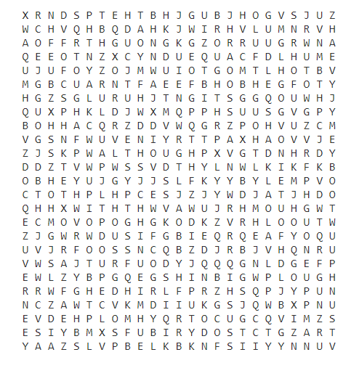

Super SPAG Challenge:
- Write a sentence that includes an ough word and a relative clause
- Write a sentence that includes an article determiner, an ough word and a semi-colon.
- Write a sentence including a personal pronoun and an ough word

1.
2.
3.

