Zookeeper
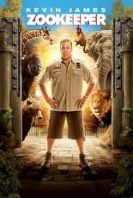
Have you ever wanted to be an animal keeper if so read on to find more information?
People in it

: Kevin James
: Adam Sand
: Joe Rogan
:Nick Nolte

Why should you watch it
I think you should watch it because if you like animals this is the right movie for you to watch you will be amazed by the animals and what they can do. It will make you laugh.
It made me laugh because the gorilla started driving and crashed right into the car and it smashed.
What its about

There was this man called kevin who worked at a zoo with lots of animals and he meat this girl called lisa and they fell out together so kevin diced to go on an ostriches back but
he fell over so the he jumped on a gorillas back and they started running and they climbed a big tower and they saw a taxi with lisa in it so kevin decide to jump onto the taxi and he hurt is arm and lisa jumped out and they started talking so then lisa kissed kevin and they were back together again.

What I rate it out
I would give it a ten/ten because it was amazing there was nothing wrong in it.
By Oliver.S

