Giraffes

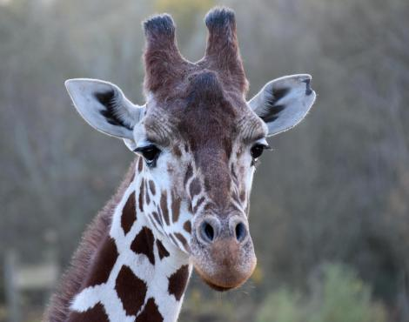

Facts
: Giraffes are the tallest mammals on earth.
: They can run over 35milles per hour.
: Giraffes ' necks are too short to reach the ground.

Diet

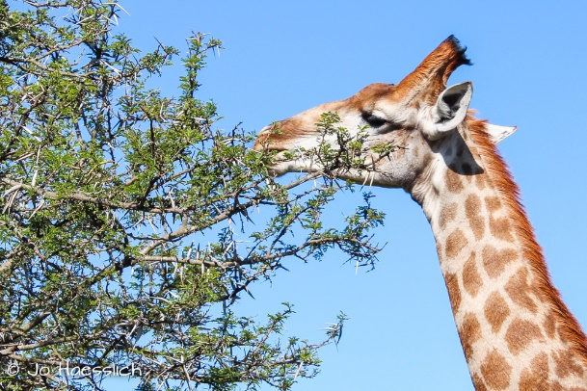

Giraffes are herbivores which only eat plants. Their necks can let them reach the tall leaves. They eat: leaves, seeds, fruits, buds and branches and they have a very healthy diet.

Their habitats

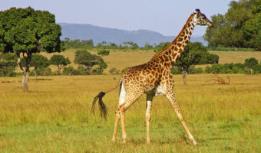

They mainly live: woodland, grassland and savanna

Interesting facts

Like humans have different fingerprint Giraffes and pants on their body so they are not all not the same like humans. When they eat a lot they only poop out maltesers. They only drink and then for the whole few days they dont drink alot.

