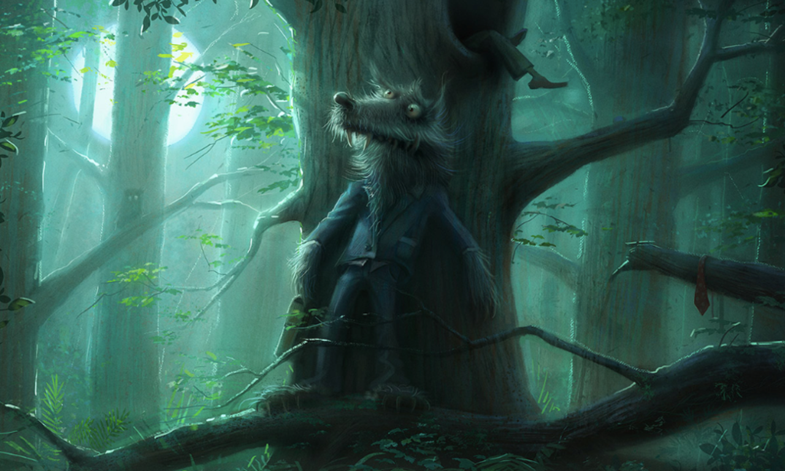In the deepest, darkest depths of the forest, Mr. Wolf waited.
His disguise hadn’t worked, but that didn’t concern him. Now, the boy thought he was safe. Mr. Wolf didn’t think he was. Mr. Wolf knew exactly where he was. He could sense him. He could smell him. He could almost taste him…
Mr Wolf peaked around the tree; he saw the boy slowly and carefully walking towards the tree, the boy was looking cautiously around, trying to seek out Mr Wolf.
Mr Wolf then peered around the other side of the tree. The boy had disappeared. Mr Wolf quickly hid behind the tree again, wondering where the boy vanished to.
All of a sudden, the boy jumped out from behind the tree and said “I found you”, Mr Wolf had been caught. It was now his turn to find the boy. The boy then skipped off into the woods shouting “I bet you can’t find me”. Mr Wolf sighed, then turned to the tree and started counting to 100.

