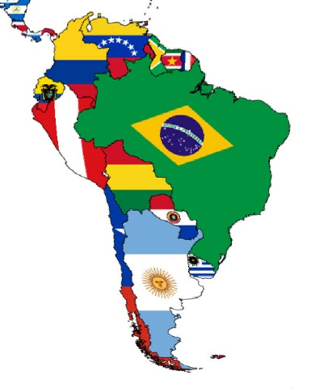
Year 5’s Creative Homework Task – Summer Term 2
Our Creative Homework Project this half term will be to create a presentation about one of the countries of South America; below is a list of countries. The project can either be typed (presented as a PowerPoint or a Word document) or hand-written on paper or card. Pictures, photographs and fun-facts will add interest. The project can be handed in when the children are ready to bring them into class to share with the class.
Thank you.
List of Countries for Creative Homework Project
Country
Argentina
Bolivia
Brazil
Chile
Colombia
Ecuador
Guyana
Paraguay
Peru
Suriname
Uruguay
Venezuela

