Here are some ideas for your home learning this week.
Please complete some extra homework if you are back.
Our topic is called ‘Why were the Mayans marvellous?’
Some ideas will be based on the themes we are covering in class.
Literacy and Communication | Writing  A day in a Mayan Village …  Write a diary entry describing a day in your using the research you have already done in school. What are your tasks? How do you tend to the maize? Who takes the crops to market? Describe your routines and any concerns you have as it has been such a long time since it rained. Do you think the gods are angry with you?  You might include….  • Dialogue with customers at the market  • Use the past tense  • Describe how you felt as well as what you did  SPAG  Refresh your memory about using commas using this bitesize lesson:  https://www.bbc.co.uk/bitesize/articles/zdy8qnb
Maths and Problem Solving | Complete the following lessons about ratio:  https://www.bbc.co.uk/bitesize/articles/z6tcf82 - introduction to ratio  https://www.bbc.co.uk/bitesize/articles/zqsjcmn - represent and calculate ratio  Mymaths.co.uk: complete- introducing ratio, introducing proportion  Can you crack the Mayan number system? Use the key to decode the numbers on the attached activity sheet.
Science and the outside environment | Use this bitesize lesson to find out how blood and the heart work together:  https://www.bbc.co.uk/bitesize/articles/zq6x8hv  Using the information in this guide, design a fact sheet or poster to explain what and how the circulatory system works.
Creative Arts | Design and create your own Mayan glyph using cardboard/string: https://funandeducationalactivitiesforkids.com/home/make-an-ancient-mayan-glyph-learn-about-maya-civilization  Create your own Worry doll following these simple instuctions:  https://www.youtube.com/watch?v=JJWmReMZSAA
PHSE | Look at the attached activity about online attention- how do you know if the attention you are getting of someone is good or bad?  What can you do about it?  How can you cope with stress?  Look at the following clips:  What is stress?  https://www.youtube.com/watch?v=09Rnq-FhnGs  Effects of stress  https://www.youtube.com/watch?v=TZZlIKXcolo  How stress can affect your body:  https://www.youtube.com/watch?v=AlMfEL_sCYI  How can I manage stress?  https://www.youtube.com/watch?v=hnpQrMqDoqE  strategies to reduce stress  https://www.youtube.com/watch?v=0fL-pn80s-c  Now draw and label little pictures of things you can do, when you are feeling pressure/tension/stress.
Physical Education | Continue with the lockdown PE challenge: how many can you complete this week? Try and set a challenge of completing at least one activity per day.
Humanities and Citizenship | The Maya had two calendars that they used- research how the Maya used their calendar using:  https://mayaarchaeologist.co.uk/2016/12/31/maya-calendar-system/-watch  Follow instructions to make a Mayan calendar using templates  https://mayaarchaeologist.co.uk/2017/03/31/maya-calendar/- have a go at finding a date using the calendar. Can you answer the quiz questions on web page?
Reading | 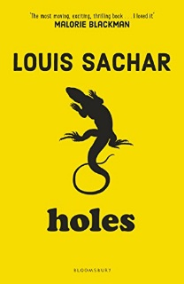  Reading:  Group 1- complete the comprehension questions attached about ‘Can you see me now?’  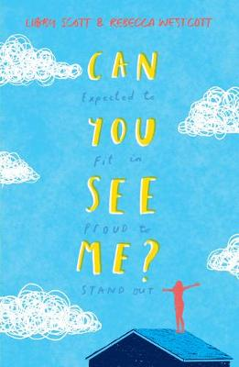  Group 2- complete the comprehension questions attached about ‘Holes’
Times tables | Do not forget to continue to practise your timetables. Spend 10 minutes a day at least on TT Rockstars. https://ttrockstars.com/  Complete the attached arithmetic test.

