Literacy and Communication | Writing  Use the following link- complete the 5 set lessons on Information leaflets: https://www.thenational.academy/online-classroom/year-6/english#subjects  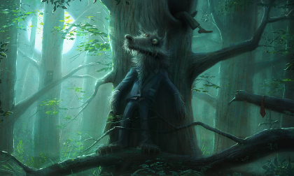  Look at the attached story starter: ‘The Wolf’ can you continue the story.  Try to use parenthesis- brackets, dashes or commas.  Can you use a range of punctuation including colons (:) and semi-colons (;)  SPAG  Complete the commas task.  Spot the spelling mistakes.
Maths and Problem Solving | Download the Y6 pack- we recommend that you do 1 activity per day. Follow the video links for extra help. https://whiterosemaths.com/homelearning/  Work through the calculating angles PowerPoint and complete the activity.  Mymaths.co.uk: complete- Angles in parallel lines, Angle reasoning
Science and the outside environment | Complete the activity: Grow your own crystals. Please send in photographs of how they turn out.  Use the following link to revise knowledge about evolution: https://www.thenational.academy/year-6/foundation/what-is-the-theory-of-evolution-year-6-wk1-3
Humanities and Citizenship | 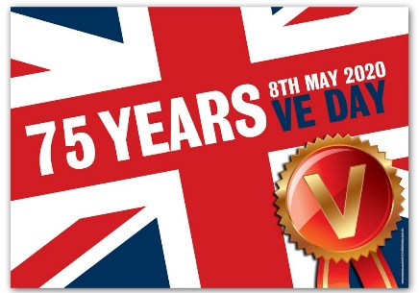  We will celebrate VE Day on 8th May.  Watch the following clip to find out information about why VE day is important:  https://www.mrtdoeshistory.com/ve-day-key-stage-2  https://www.bbc.co.uk/teach/class-clips-video/history-ks2-ve-day/z7xtmfr  Can you make some VE Day bunting to decorate your door? There is a link here with an idea of how to make it but be creative and use your own designs too.  https://www.bakerross.co.uk/craft-ideas/teachers/ve-day-anniversary-colour-in-bunting/
Computing | Check this website for daily ideas and lessons: https://www.bbc.co.uk/bitesize/subjects/zvnrq6f
Creative Arts | Complete the ‘Texture treasure hunt’ lessons:  https://www.thenational.academy/year-6/foundation/texture-treasure-hunt-year-6-wk1-5  Please send in samples of your work for me to update the blog.
Physical Education | Have a go at some disco yoga:  https://www.youtube.com/watch?v=PSgZl8f5leU  Try a 10 minute Disney shake up:  https://www.nhs.uk/10-minute-shake-up/shake-ups  Try this Dance workout:  https://www.youtube.com/watch?v=L_A_HjHZxfI
Reading | Reading:  Read the extract ‘The tale of Angelino Brown’  Complete the attached activities linked to the text.
Times tables | Do not forget to continue to practise your timetables. Spend 10 minutes a day at least on TT Rockstars. https://ttrockstars.com/  https://mathsframe.co.uk/en/resources/resource/486/Y6-Arithmetic-Practice

