Literacy and Communication | Writing  Continue to work through the ‘City of silence’ workbook. Look at the suggested activities for the second week.  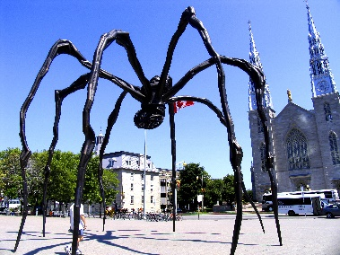  Look at the ‘Maman’ sculpture attached- can you complete any of the suggested activities? Write a story about what would happen if the sculpture came to life…  SPAG  Complete the attached activities:  1- hyphens, brackets and dashes  2- colons and semi colons
Maths and Problem Solving | Watch the video links on: https://whiterosemaths.com/homelearning/ There is a break next week but instead complete the lessons for the week beginning 1st June based on fractions, decimals and percentages.  Complete the attached activities- aim to do 1 activity per day.  Look at the first 5 lessons on fractions at https://www.thenational.academy/online-classroom/year-6/maths#subjects  Mymaths.co.uk: complete- modelling fractions and percentages, modelling percentages and percentages of amounts.
Science and the outside environment | My Science Share 2020 activities. This week’s theme is ‘Waste warrior week’  Share your questions about waste and making the most of our resources.  Things children may wonder about…  How many miles has my lunch travelled to reach me?  How long does it take for my empty bottle of water to be reused?  Which everyday materials are recyclable?  Have a look at the following websites for ideas:  - https://www.rspb.org.uk/fun-and-learning/for-families/family-wild-challenge/activities/build-a-minibeast-hotel/  - https://www.rspb.org.uk/globalassets/downloads/documents/kids-and-schools/make-a-bottle-bird-feeder.pdf  - https://www.rspb.org.uk/globalassets/downloads/documents/kids-and-schools/make-a-butterfly-bar.pdf  - https://practicalaction.org/schools/plastics-challenge/  Can you complete the attached activity about climate change?
Humanities and Citizenship | Continue your ‘Anywhere Island Part 3’  Can you make a persuasive holiday brochure for your island?  You may use the template or have a go at making your own brochure. Maybe you could show off your word processing skills.
Religious Education | Eid-al-Fitr was celebrated by many Muslims over the weekend to mark the end of Ramadan, a month-long event where Muslims fast from dawn to sunset each day.  Read the information about Eid and answer the inference questions  Watch the clip below showing how some Muslims have mehndi patterns to celebrate Eid. Look at the attachment on the home learning page – can you create a mehndi design for Eid?  https://www.bbc.co.uk/cbeebies/puzzles/lets-celebrate-eid
Creative Arts | Can you create a picture that represents your time at home? Maybe you can make a photo collage using a computer/tablet. Maybe you could make a comic strip? Use whatever inspires you and get creative!
Physical Education | https://www.nhs.uk/10-minute-shake-up/shake-ups  If you fancy something more challenging have a go at  https://www.fitnessblender.com/ You can watch videos featuring a range of exercises and workouts. You can choose exercises by: degree of difficulty, type, gender and whether equipment is needed or not.
Reading | Reading:  Read the extract ‘Nancy Parker’s spooky speculations’  Answer the attached questions- no need to print them out just write doen your answers in a notebook or on a computer.  Use https://readtheory.org/auth/login to practise some comprehension work.
Times tables | Do not forget to continue to practise your timetables. Spend 10 minutes a day at least on TT Rockstars. https://ttrockstars.com/  https://mathsframe.co.uk/en/resources/resource/486/Y6-Arithmetic-Practice

