Here are some ideas for your home learning this week.
Please complete some extra homework if you are back.
Our topic is called ‘Why were the Mayans marvellous?’
Some ideas will be based on the themes we are covering in class.
Literacy and Communication | Writing  Research the lost Mayan city- Tikal.  https://www.history.com/topics/ancient-americas/tikal  You have been commissioned to create a leaflet to encourage tourists to visit the ancient Kingdom of Tikal. Think about all the riches it has to offer: historically and geographically.  Where would you advise tourists to go? To take a canoe ride on the river; to explore the inside of a pyramid; or go on a trek into the lush rainforest?  You might include…  • maps and illustrations  Remember…  • Use powerful persuasive language: lots of adjectives and exaggeration:  ‘fragrant aromas drifting across the breeze’; ‘proud pyramids standing strong…’  SPAG  Use semi colons to organise the information in your leaflet. Use this lesson template to refresh your memory of how to use semi colons:  https://www.bbc.co.uk/bitesize/articles/z98vtrd
Maths and Problem Solving | Complete the following lessons about ratio:  https://www.bbc.co.uk/bitesize/articles/z6rsm39 - angles in polygons  https://www.bbc.co.uk/bitesize/articles/z4vfxbk - angles in quadrilaterals  https://www.bbc.co.uk/bitesize/articles/z8twr2p- angles in triangles  Mymaths.co.uk: complete- parts of a circle, angle sums, mixed assessment 8
Science and the outside environment | Read the attached ‘All about blood’ slideshow  Download the attached activity- can you follow the instructions to make your own bottle of blood?  Remember to take a photograph and send it in to school.
Humanities and Citizenship | Read the attached information about ‘Maya food’  Create your own inventory of Mayan foods. Make your inventory bright, colourful and informative and ensure that you include a range of foods
DT | Can you design a Mayan recipe?  Use your research about Mayan foods to create a recipe using some of the food that they had available.  Can you make your recipe?  I have attached two recipes that you could try- hot chocolate or tortilla.  Send in a photograph of anything that you have a go at making/designing?  You can use the attached recipe template sheet or create one of your own.
Physical Education | Active Tameside are doing PE lessons online check out their website  https://www.activetameside.com/bhangra-dance-pe-dance-lesson-with-lianne/
PHSE | Can you write a letter to your secondary school? Look at the attached guide to help you think of some ideas to include.  Complete the ‘transition time capsule’. Put this somewhere safe so that you can look back at it in the future.  Complete the ‘my school year memory page’ What a year it has been! What have been your highs and lows? Think all the way back to when we went to Rock and River in September.
Reading | 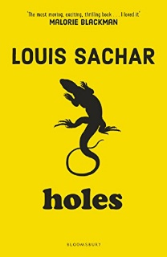  Reading:  Group 1- complete the comprehension questions attached about ‘Can you see me now?’  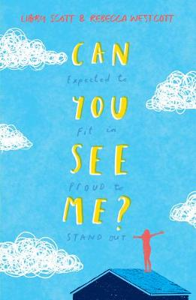  Group 2- complete the comprehension questions attached about ‘Holes’
Times tables | Do not forget to continue to practise your timetables. Spend 10 minutes a day at least on TT Rockstars. https://ttrockstars.com/

