Topic | Rivers and Mountains  Hi everyone, I hope you are all doing well at home. I’m Miss Glenn who you met back in February and I’ll be doing your Home Learning now. Remember just do what you can but make sure you challenge yourself. I would love to see what you have done from this weeks Home Learning. Please forward any work or questions to admin@broadbentfold.tameside.sch.uk
Literacy and Communication | These are the 4 highest peaks in the UK.  Ben Nevis, 1344 metres, Scotland.  Snowdon, 1085 metres,  Wales.  Scafell Pike, 987 metres,  England.  Slieve Donard, 850 metres, Northern Ireland.  Can you research the mountains and go on a virtual holiday there? Then send me a virtual postcard from one, two, three or even four of tghem. Tell me what it’s like, what’s the weather like up there? What facilities are there? What information do you know about each mountain? What kit do you need? Did anything exciting happen? Keep it factual, first person and informal.  https://kids.kiddle.co/List_of_mountains_and_hills_of_the_United_Kingdom |  | Spelling, grammar and punctuation.  Download the up levelling sentences document and choose a sheet to complete. | Revise some of the Year 5/6 spelling list attached and create mnemonics, doodles etc Anything that will help you remember them. 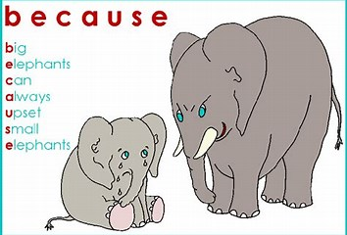
Maths and Problem Solving | Complete some of the Year 5 revision booklet. Download and print if you can but if not don’t worry, just do the ones you can on some paper. Check your answers when you finish. | MyMaths has been set. Please have a go at completing the work on the website. Login: Broadbent, Password: boostbroadbent. |  |  |  | Look at the activities and aim to do one lesson a day. https://whiterosemaths.com/homelearning/year-5/
Science and the outside environment | Find out how Mountains are formed and create a diagram.  https://www.bbc.co.uk/bitesize/topics/z849q6f/articles/z4g3qp3 | Forces- air resistance  Watch the first video on the link and think about what difference an aerodynamic shape makes. Make a paper aeroplane and see which is the most aerodynamic shape you can make. Which will go the furthest? Can you measure it to find out? Why do you think this is? Think about a variable-what you will change. Think about making it a fair test-what stays the same?  https://www.bbc.co.uk/teach/terrific-scientific/KS2/z7smscw
Humanities and Citizenship | Research the 7 highest Mountain Peaks in the world. Produce a factsheet about where they are. Which continent are they in? How high are they? You can write, use maps, illustrations and labels. Anything you like. | In these difficult times it is perfectly normal to feel anxious. Find a quiet space to follow this clip and focus on your breathing. This may help you feel calmer. Try to do this everyday or whenever you feel worried.  https://www.bing.com/videos/search?q=minfulness+for+kids&docid=608039778169324061&mid=48450A71D379FAB94B4C48450A71D379FAB94B4C&view=detail&FORM=VIRE
Creative Arts | I would love a sketch of your favourite thing at home. Can you sketch one for me. I’m going to do one of my puppy Billy. I’ll post it on the blog for you all to see. If he’ll sit still long enough! | Can you use household items to create a mountain? This could be using salt dough, Papier Mache, or simply objects you can balance to make a mountain. Get as creative as you like. Good Luck!
Physical Education | Follow this link for some yoga.  https://www.youtube.com/user/CosmicKidsYoga/videos | Lets have a walking competition. Find a space in your house/garden or during your daily exercise. Count how many steps you do everyday or how long you walk everyday. Can you do as much as Colonel Tom? While you do it reflect on why people do things for charity. Why is it important? How can you make a difference to someone today?  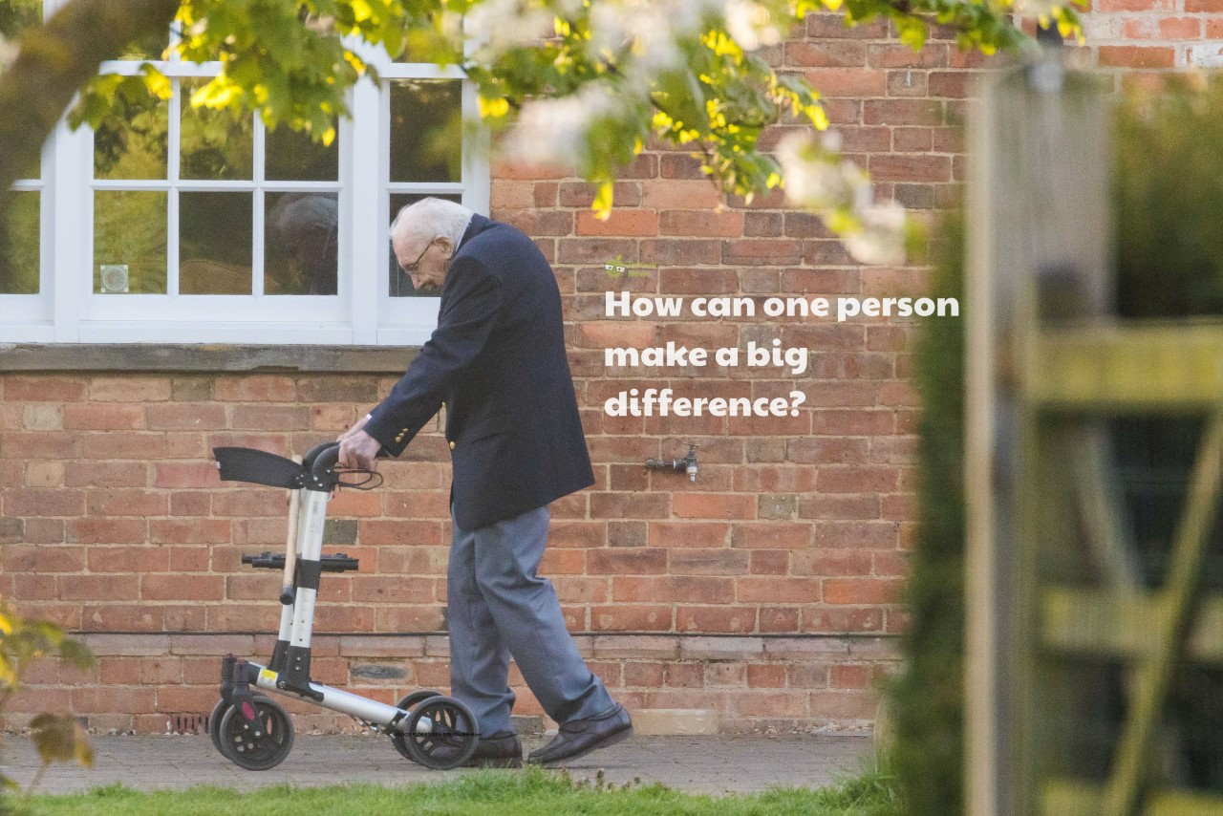
Reading | Remember to aim for 30 minutes a day. Don’t forget your research reading counts but do as much as you can ready for Year 6. | Don’t forget to log on to BugClub to read books and answer some comprehension questions. |  |  | Love reading for kids has lots of great extracts of books. Have a read to find a book you might want to read fully.  https://www.lovereading4kids.co.uk/
Times tables | I would love to know how well you know your times tables. Can you show me? You can do this in the way you most enjoy. | Don’t forget to log on to  TT rockstars for some practise. |  |  | Can you create a times tables rap.  e.g 2 x 4 is 8 now close that gate…….

