Topic | Rivers and Mountains
Literacy and Communication | Can you plan out an adventure story and then write it. Use the tools attached to help you. You will find a word bank, good examples and lists of what should be included as much as possible. Remember adventures are exciting so you should try and you’re your reader in as soon as possible. Can you link in mountains and rivers in some way? Can’t wait to read them I’ve run out of books! |  |  | https://www.theschoolrun.com/what-are-active-and-passive-sentences  Look at this link to understand active and passive voice then try the activity attached. |  | Use the link to understand a relative clause and complete the attached activity.  https://www.bbc.co.uk/bitesize/topics/zwwp8mn/articles/zsrt4qt
Maths and Problem Solving | Please see the attached line graph and timetable activities. |  |  | MyMaths has been set. Please have a go at completing the work on the website. Login: Broadbent, Password: boostbroadbent. |  | Look at the daily lessons available on this link.  https://www.ncetm.org.uk/resources/54454
Science and the outside environment | https://www.greatscienceshare.org/getinvolved2020#weekly-themes-2020-wk4  Look at the above attachment for information about this weeks science share theme and try the following activity on the link below. https://docs.google.com/presentation/d/1Y7r41G2rKj90wDM1LVtGe18tAMq8qnlkHKXIEMCbCIs/edit#slide=id.g804d135a4d_3_161 |  |  | See the attached sheets on water resistance an complete the boat investigation. 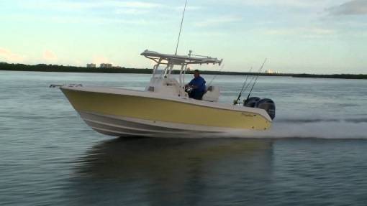
Humanities and Citizenship | https://canalrivertrust.org.uk/explorers/learning-from-home/rivers  https://canalrivertrust.org.uk/explorers/learning-from-home/canal-and-river-habitats  Try these links to find out all about rivers and canals, there are a huge amount of activities to choose from. I’d be happy to see any of your choice. Have fun in your learning. | https://www.thinkuknow.co.uk/parents/Support-tools/home-activity-worksheets/8-10s/?utm_source=Thinkuknow&utm_campaign=e9ea1fa21d-TUK_ONLINE_SAFETY_AT_HOME_19_05_20&utm_medium=email&utm_term=0_0b54505554-e9ea1fa21d-64877997  Try these online safety packs. |  | https://www.bbc.co.uk/newsround/52557800  Look at this news clip on mental health awareness week and the importance of being kind. Read all the information, there is a lot if you scroll down. Then do a poster/leaflet showing and explaining why kindness is so important.  And remember……be kind to each other.
Creative Arts | https://www.happyfamilyart.com/art-lessons/art-history-for-kids/pointillism-georges-seurat-art-lesson/  Look at the artist and try pointillism on a subject of your choice. |  |  |  | https://www.stem.org.uk/system/files/elibrary-resources/2016/01/How%20do%20you%20take%20your%20tea%20%28full%20colour%29.pdf  This is a great Design and Technology project all about making tea. Make sure you are supervised by an adult and have their permission first as it involves hot water. For the record I take my tea strong but milky!
Physical Education | https://www.youtube.com/results?search_query=pe+lessons+with+joe+wicks  Try any of these PE lessons with Joe Wicks you may have missed. |  |  | https://www.youthsporttrust.org/pe-home-learning  Try some of these super home learning ideas for PE, there are loads to choose from.
Reading | Don’t forget to log on to BugClub to read books and answer some comprehension questions. |  |  | Use the attached book review sheet to review some of the books you have been reading at home.
Times tables | Don’t forget to log on to  TT rockstars for some practise. |  | https://www.youtube.com/watch?v=C3PojOwjHcc  Can you learn these times tables songs to help you remember. Skip to the ones you are working on if you want to.

