Topic | Rivers and Mountains  Hello. I hope everyone is staying safe and well. I’ve had some fantastic work in and it’s great to see all the wonderful things everyone is getting up to. I’m looking forward to seeing what you do this week. Please forward any work or questions to admin@broadbentfold.tameside.sch.uk
Literacy and Communication | Create a presentation on rivers using multimedia. This could be on PowerPoint, word, a video, a leaflet on the computer. Use digital images to bring it to life.  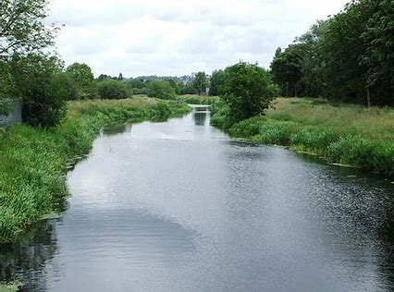 |  | Spelling, grammar and punctuation.  Download the Determiners PowerPoint and work through to learn what they are. Then choose a determiners sheet to complete. | https://spellingframe.co.uk/spelling-rule/5/Year-5-and-6  Use this website to work on your spelling sounds. There is a free game on each link.
Maths and Problem Solving | Complete the Year 5 PowerPoint on position and direction then try a worksheet. Download and print if you can but if not do not worry, just do the ones you can on some paper. Check your answers when you finish. | MyMaths has been set. Please have a go at completing the work on the website. Login: Broadbent, Password: boostbroadbent. |  |  |  | Look at the activities and aim to do one lesson a day. https://whiterosemaths.com/homelearning/year-5/
Science and the outside environment | During your daily exercise think about all the different examples of air-resistance, friction and gravity you see. Keep a scientific log.  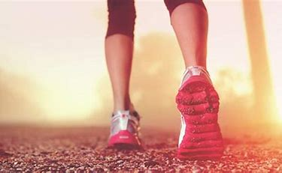 | Forces- friction  Download the investigation and using this as a guide have a go at doing your own friction shoe investigation. I know you won’t have a force meter but be creative. How else could you measure the friction of different surfaces? Which will allow the shoe to go the furthest? Can you measure it to find out? Why do you think this is? Think about a variable-what you will change. Think about making it a fair test-what stays the same?
Humanities and Citizenship | Find out where rivers begin. How are they formed? Create a river glossary explaining all the river terms you find out. You could do this as a poster or a table.  Can you name all the rivers in the UK and locate them on a map?  Use this website as a good starting point. http://www.primaryhomeworkhelp.co.uk/rivers.html | Our RE topic this term is what would Jesus do? The topic question is: Can people live by the value of Jesus in the 21st century. The value to think about this week is generosity. Try to think about how people have lived by this value during the lockdown. Have people been generous in different ways as well as money? Create a spider diagram of all the different ways people have been generous during this difficult time. Include anything you have done yourself.
Creative Arts | Can you create a realistic sketch or painting of a river like this one? Follow the link first to find out about different techniques you might need.  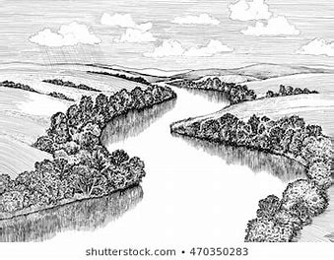https://www.bbc.co.uk/bitesize/clips/zvq6sbk
Physical Education | Follow this link to learn a dance routine.  https://www.bing.com/videos/search?q=dance+routines+for+kids&&view=detail&mid=6C2A8771BE4C99FDAD506C2A8771BE4C99FDAD50&&FORM=VRDGAR&ru=%2Fvideos%2Fsearch%3Fq%3Ddance%2Broutines%2Bfor%2Bkids%26FORM%3DHDRSC4 | Make sure you are getting plenty of exercise, take pictures to show me all the inventive ways you are getting your important daily exercise.
Reading | Remember to aim for 30 minutes a day. Did you manage to read somewhere unusual for the competition. If not give it a go.  Also you could find your favourite place to read, a quiet spot, your bedroom, the garden and try to really get into a book you’re reading. We maybe staying in but a book can take you anywhere using your imagination! | Don’t forget to log on to BugClub to read books and answer some comprehension questions. |  |  | Love reading for kids has lots of great extracts of books. Have a read to find a book you might want to read fully.  https://www.lovereading4kids.co.uk/
Times tables | Work on the times tables you are least confident in. See if you can increase your speed every time you do them. Time yourself. Then work on the division associated with it.  e.g 3 x 6 = 18  so 18 ÷ 6 = 3 | Don’t forget to log on to  TT rockstars for some practise. |  |  | Can you find all the related facts to the times tables you are working on.  E.g if 3 x 6 = 18  Then 30 x 6 = 180  And 30 x 60 = 1800

