Home Learning Grid – Reception  W/B 2nd November 2020  Here is an outline of this week’s home learning activities for Reception for any children self isolating. Please choose as many as you can (remember there are activities on Seesaw, Education City and attached to the blog too). Don’t feel you have to do everything! | Please keep reading your books. I have put three in your bags for while we are learning at home. Please also learn the following tricky words:-  the to no go  I into | Name Writing  This week I would like you to practise writing your name, forming each letter correctly. Once you can write your first name, move on to your surname.
Bonfire Night  I would like you to design a firework display and label all the different noises they make eg pop! Bang!, Fizz! Crack! | Ordering Numbers  This week I would like you all to practise ordering numbers to 20. I have attached a sheet for those who have a printer. Just write them out if not or miss some numbers out and get your child to write in the missing number. | Diwali  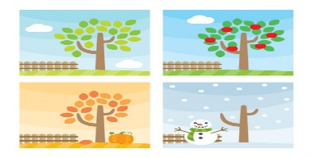  This week I would like you to have a go at some Diwali crafts after watching the video below. You could make a lantern, a diva light or some rangoli patterns.  https://www.bbc.co.uk/cbeebies/watch/lets-celebrate-diwali
Physical Activity Ideas

https://www.youtube.com/watch?v=KAT5NiWHFIU

