Topic | Hi all and welcome back. I hope you had a nice break. Our new topic is Anglo Saxons and I can’t wait to see some of your learning for this. Don’t forget to email in anything you are doing towards this or just your general wider learning. Thanks everyone.
Literacy and Communication | Anglo Saxon poetry was supposed to be orally rehearsed and performed. This is how the poems would have been passed on through time. Kennings poems are from this time period and describe something without saying what it is.  Follow this link and look at the PowerPoint to help you, Then write your own Kennings poem and see if we can guess what or who you wrote about.  https://www.theschoolrun.com/what-is-a-kenning |  | Can you show me an example of your best handwriting for the following phrase. Try and do it a few times until you are happy you have improved. 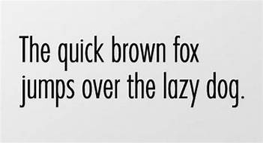 |  | Use the link to understand modal verbs and complete the quiz.  https://www.bbc.co.uk/bitesize/topics/zwwp8mn/articles/zps4pbk
Maths and Problem Solving | Please see the attached fractions decimals and percentages activities after reading this explanation.  https://www.mathsisfun.com/decimal-fraction-percentage.html  Also try this game.  https://www.bbc.co.uk/teach/class-clips-video/converting-fractions-decimals-and-percentages/zk9ygwx |  | MyMaths has been set. Please have a go at completing the work on the website. Login: Broadbent, Password: boostbroadbent. |  | Look at the daily fractions lessons available on this link.  https://www.ncetm.org.uk/resources/54454
Science and the outside environment | https://www.greatscienceshare.org/getinvolved2020#weekly-themes-2020-wk6  Check out the weekly theme on world oceans week and tell me something you didn’t know. |  | https://worldoceanday.school/  It is world ocean day on 8.6.20. Choose one or more of these amazing lessons/activities to find out about. What are you passionate about the ocean? Helping to keep it clean, the wildlife or the health benefits. Create a presentation.
Humanities and Citizenship | For RE find out about how Anglo Saxons converted from Pagan worship (worshipping many gods with superstitious beliefs) to Christianity (worshipping just one God). Create a piece of writing to explain this. |  | What are the origins of Anglo Saxon Britain? Create a timeline that shows their place in history between the Romans and the Vikings. Illustrate and include facts. See example below.  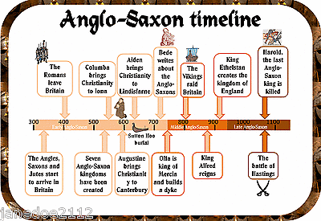
Creative Arts | Research, design and create an Anglo Saxon house.  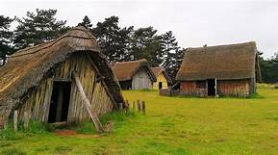 |  |  | Can you draw some Anglo Saxon artefacts and label them to explain what they are and what they were used for?  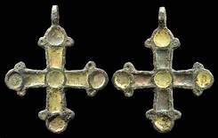
Physical Education | https://www.bbc.co.uk/bitesize/subjects/zj6pyrd  Try some of these PE lessons from BBC Bitesize. |  | https://www.youtube.com/watch?v=zzWyMWAEfk4  Can you complete this speed bounce challenge.
Reading | Don’t forget to log on to BugClub to read books and answer some comprehension questions. |  | https://www.talk4writing.com/wp-content/uploads/2020/05/Y5-One-Chance.pdf  Try these reading and writing activities.
Times tables | Don’t forget to log on to  TT rockstars for some practise. | https://www.timestables.co.uk/  Learn any you are unsure of until you know them inside out, upside down and back to front. They will really help in Year 6 which such a range of learning.

