**TOP**

**SECRET**

**MISSION**

FRICTION INVESTIGATION

C:\Users\Jady\AppData\Local\Microsoft\Windows\Temporary Internet Files\Content.IE5\X2BGX4JZ\MC900440060[1].wmf

AGENT _________________________

Hello Agent,

Jamie Bond needs your help! When chasing the baddies on his last mission, he slipped!

*Friction occurs when two surfaces are in contact with one another.*

Jamie Bond’s shoes did not generate enough friction when running and…

**The bad guys got away!**

**Your Mission**

You need to find out how much force is needed to move a shoe across different surfaces.

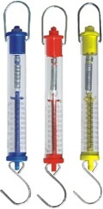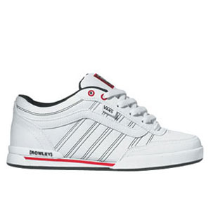

**You will need:**

* Your secret agent workbook
* A pencil
* A sports shoe
* A forcemeter
* A selection of surfaces

**Planning Board**

**Question:** How much force is needed to move a shoe across different surfaces?

**What will we do?**

**What will we measure?**

**What will we change?**

**What will we keep the same?**

**Will we need to repeat any measurements? Why?**

**Predictions:**

I think the shoe will be easier to pull on __________ because

I think the shoe will be harder to pull on __________because

­­­­­­____________________________________________________________________

**REMEMBER….**

It has to be a FAIR TEST

This means….

**­­**

**__________________________________**

**Results**

|  |  |  |  |  |
| --- | --- | --- | --- | --- |
| **Surface** | **Force Needed to Start Shoe Moving** | | | |
|  | **1** | **2** | **3** | **Mean** |
| **Surface 1** |  |  |  |  |
| **Surface2** |  |  |  |  |
| **Surface 3** |  |  |  |  |

|  |  |  |  |  |  |  |
| --- | --- | --- | --- | --- | --- | --- |
| 4.0 |  |  |  |  |  |  |
| 3.8 |  |  |  |  |  |  |
| 3.6 |  |  |  |  |  |  |
| 3.4 |  |  |  |  |  |  |
| 3.2 |  |  |  |  |  |  |
| 3.0 |  |  |  |  |  |  |
| 2.8 |  |  |  |  |  |  |
| 2.6 |  |  |  |  |  |  |
| 2.4 |  |  |  |  |  |  |
| 2.2 |  |  |  |  |  |  |
| 2.0 |  |  |  |  |  |  |
| 1.8 |  |  |  |  |  |  |
| 1.6 |  |  |  |  |  |  |
| 1.4 |  |  |  |  |  |  |
| 1.2 |  |  |  |  |  |  |
| 1.0 |  |  |  |  |  |  |
| 0.8 |  |  |  |  |  |  |
| 0.6 |  |  |  |  |  |  |
| 0.4 |  |  |  |  |  |  |
| 0.2 |  |  |  |  |  |  |
|  |  | Surface 1 |  | Surface2 |  | Surface3 |

**Bar Chart of Results**

Title_______________________________________

Label:

Label:

**Results:**

The surface that has the most friction was ___________

The surface that had the least friction was ___________

**Did you expect this ? Why?**

**­­_____________________________________________**

**_____________________________________________**

_____________________________________________

**Was there anything else affecting your results?**

**____________________________________________**

_____________________________________________

_____________________________________________

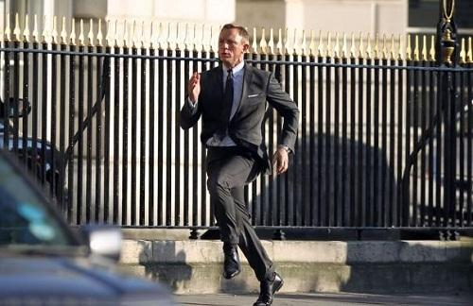

With more *friction* between the shoe and the surface, more force was needed to make the shoe move

Agent ______________

Top Secret Location

T0P SCRT

Date: _______________

Dear Jamie Bond,

We have completed our secret mission and we have found out that:

You should avoid __________________ when chasing the baddies because this surface generates _________ friction.

You should chase them on _______________________ because this surface generates _____________ friction.

We also found out _____________________________

____________________________________________

Yours Sincerely,

Agent ___________________________________

Teacher

Resources:

* Lesson Plan
* Complete Planning Board

|  |  |  |  |
| --- | --- | --- | --- |
| **Lesson Plan** | | | |
| **Year:** | | **Date:** | |
| **Topic: Science – Forces - Friction** | **National Curriculum Links:**  **Science SC4: Physical Processes:** 2c, 2d, 2e, | | **Cross Curricular links:**  **Maths MA4: Handling Data: 1a, b, c, d, e, f, 2a, b, c, d, f** |
| **Previous Knowledge/Misconceptions:**  Friction is notoriously difficult to teach primary school children because many of the concepts are counter intuitive and there are a host of common misconceptions that can be extremely difficult to challenge. See **Primary Science: Teaching the Tricky Bits** by Neil Rutledge, Ch. 18 and 19 | | | |
| **Learning Objectives:**   * To understand that friction can occur when two surfaces are in contact with each other | | | |
| **Success Criteria (I can…)**   * **Identify things to measure or observe that are relevant to the question (AF4, L2)** * **Identify one or more control variables (AF4, L3)** * **Make sets of observations or measurements (AF4, L4)** | | | |
| **Differentiation:**  **Children set in ability groups from 3c – 4a**  **Introduction of the mean average – teacher to work out if needs be.**  **Bar chart to complete if children get that far.** | | **Resources:**  **Manilla file with Top Secret stamped on it**  **James Bond theme tune**  **Photocopied workbooks**  **Newton Meters / Force Meters**  **PE pumps or Trainers**  **Surfaces: Gravel, Grass, Wood (bench) , Plastic, Vinyl, Carpet – any other surfaces the children can find and would like to use** | |
| **Assessment:**  **Assessment by task – carry out a fair test; recording accurate results in a table (and bar chart)**  **Assessment by observation – discussions with other groups comparing own results with others and drawing conclusions.** | | | |
| **Introduction: 10 minutes**  **Children enter class to James Bond Music after break, Teacher to act secretive.**  **Tell the children that Jamie Bond has been in touch and would like to recruit our help with a secret mission.**  **Remind children of the slope and car experiment from previous session. Ask them to think about what would happen if the slope surface was changed.**  ***Friction is a force which exists between objects moving across solid surfaces and opposes motion*.**  **Go through the planning board together as a class to make sure everyone knows what they are doing**  **Key Vocabulary: Force, friction, opposes, motion, grip, surface** | | | |

|  |
| --- |
| **Main Activities: TIME 30 Mins**  Class to be split up into groups of 4 by class teacher based on ability sets.  Class to work as groups completing the workbook provided.  After groups have got their results, they should go to the class teacher and be either informed how to work out the mean or for the class teacher to do it for them.  **Extension Activities:**  Children to complete the bar chart based on their results and to answer the question sheet provided in work pack  **Other Adults:**  TA to work with mid ability groups outside to measure results on the gravel, grass and wooden bench. |
| **Plenary: TIME 10 mins**  Go through the results as a whole class comparing results with those outside the classroom.  Where was least easy to move the shoe? Which location surface generated most friction with the shoe?  Where was it easiest to move the shoe? Which location surface generated the least friction with the shoe?  Did this surprise them or is it what they predicted?  Were there any other factors affecting the outcomes of the scientific experiment?  Were there any dramatically different results? Can the children suggest why that might be?  Why were some shoes easier to move than others? (the grip on the bottom – if time get children to do a rubbing of the shoe and mention that shoes have more grip on the bottom of them to stop us from sliding – maybe we could suggest that to Jamie Bond?) |

**Teacher’s Planning Board**

**Question:** How much force is needed to move a shoe across different surfaces?

**What will we do?**

* Attach a force meter to your shoe
* Place the shoe on the surface you’re testing
* Record the amount of force needed to start the shoe moving
* Do this 3 times for every surface

**Predictions:** *(make sure the children to use scientific language)*

I think the shoe will be easier to pull on __________ because

I think the shoe will be harder to pull on __________because

­­­­­­____________________________________________________________________

**Will we need to repeat any measurements? Why?**

Yes. We need to do repeat the measurements 3 times to make sure there are no *anomalies*

**What will stay the same?**

* The shoe
* The Newton Meter

**What will we change?**

The surface that the shoe is being pulled on

**What do we need?**

* **Newton Meter**
* **Shoe**
* **Different surfaces**

**What will we measure?**

Force in Newtons