FRANCE
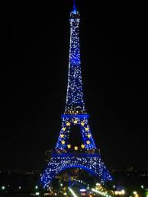
Country - France
Continent - Europe
Northern Hemisphere
Atlantic Ocean
Capital City - Paris
French language
Highest mountain - Mont blanc
Longest river - Rhine river

CHRISTMAS TRADITIONS

Homes are decorated with crèche
Mistletoe is hung up in the house for good luck
Families enjoy eating a Bûche de Noël (aka Yule Log)
Children Leave Shoes in Front of the Fireplace for Santa to fill with treats
