8. Percentage increase: Find the percentage of the amount and then add it on to the original amount.

**a) increase £200 by 50%**

**£300**

**b) Increase 450cm by 25%**

**562.5cm**

**c) Increase 34kg by 72%**

**58.48kg**

**d) increase 600miles by 48%**

**888 miles**

7. Copy and complete the table:

|  |  |  |  |  |  |
| --- | --- | --- | --- | --- | --- |
|  | 50% | 10% | 37% | 81% | 12% |
| 100 | 50 | 10 | 37 | 81 | 12 |
| 365 | 182.5 | 36.5 | 135.05 | 295.65 | 43.8 |
| 851 | 425.5 | 85.1 | 314.87 | 689.31 | 102.12 |
| 936 | 468 | 93.6 | 346.32 | 758.16 | 112.32 |

9. Percentage decrease: Find the percentage of the amount and then subtract this from the original amount.

**a) Decrease 372cm by 17%**

**308.76cm**

**b) Decrease £852 by 20%**

**£681.60**

**c) Decrease 150g by 45%**

**82.5 g**

**d) Decrease 47km by 30%**

**32.9km**

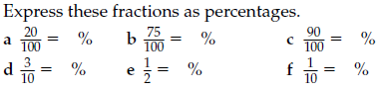

90

20

10

30

75

50

a) 20% b) 75% c) 90%

d) 30% e) 50% f) 10%

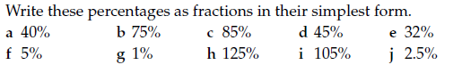

a) 2/5 b) 3/4 c) 17/20 d) 9/20 e) 8/25

f) 1/20 g) 1/100 h) 5/4 i) 21/20 j) 1/40

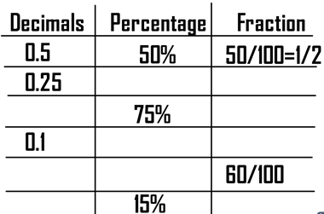



0.6 60%

0.15 15/100 = 3/20

25% 25/100 = 1/4

75/100 = 3/4

10% 10/100 = 1/10

0.75

C:\Users\rukins\AppData\Local\Microsoft\Windows\Temporary Internet Files\Content.IE5\W63X7MXS\MC900325240[1].wmf

1. Fill in the gaps on these equivalent fractions. Remember to do the same to the numerator and the denominator
2. b) c)

d) e) f)

2. Solve the following fraction multiplications and simplify your answers.

Multiply the numerators and multiply the denominators.

Example:

3. Divide the following fractions. Remember “Flip it and kiss it” so flip the second fraction and then multiply them together.

a) b)

c) d)

4. Change the following into mixed numbers.

Example:

5. Multiply these decimals.

Take out the decimal point, multiply, then put the decimal back in.

NO CALCULATORS PLEASE!

1. 4.6x7=32.2 b) 3x8.5= 25.5 c) 7.2x1.3=9.36

d) 3.5x6.9=24.15 e) 4.8x2.2=10.56 f) 6.2x8.4=52.08

g) 12.5x63.2= 790 h) 23.5x52.1=1224.35

6. Order these decimals from smallest to largest.

a) 0.83 0.883 0.08 0.8 0.0088 0.083 b) 0.632 0.634 0.064 0.006 0.6 0.63

a) 0.0088 0.08 0.083 0.8 0.83 0.883 b) 0.006 0.064 0.6 0.63 0.632 0.634

**Fractions, decimals and percentages**

[Type a quote from the document or the summary of an interesting point. You can position the text box anywhere in the document. Use the Drawing Tools tab to change the formatting of the pull quote text box.]