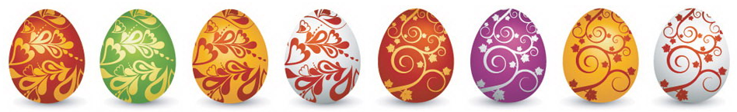

Easter Maths Challenge
ANSWERS

- The Easter Bunny can only carry 3 eggs at once. He has to choose 3 eggs from the following colours: Red, Green or Blue.

How many possible ways can the Easter Bunny carry the eggs?
(He can carry the same colour more than once)

RRR GGG BBB
RRG GGR BBG
RRB GGB BBR
RGB

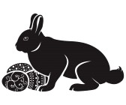

10
________________________________________________________

- At an Easter Egg Hunt there are 25 chocolate eggs hidden around the park. The park consists of 4 areas shown in the table below: Bushes, Play Area, Swings and Pond.

Complete the table:

Area Hidden: | Number of eggs: | Percentage of eggs:
Bushes | 14 | 56%
Play Area | 5 | 20%
Swings | 4 | 16%
Pond Area | 2 | 8%

________________________________________________________

- At 3 local supermarkets the following deals were on offer for Easter Eggs:
C
A

2 for £3.50
3 for £5
B

4 for £7

If I were to buy 12 Easter Eggs, which supermarket would be cheapest?
A = 4 x £5 = £20
B = 3 x £7 = £21
C = 6 x £3.50 = £21

A
________________________________________________________

4.

1/3
What fraction of the eggs are striped?

40%
What percentage of the eggs have spots?

________________________________________________________

5. A large packet of mini eggs contains 27 eggs. There are 80 children in Y8. How many packets of mini eggs should I buy so that each child gets 2 eggs?

80 children x 2 = 160 eggs

27 x 6 = 162
Therefore 6 is the minimum amount

6

_____________________________________________________

6. The following is a table to do with Easter Eggs:

Type | Weight | Cost per egg | Cost per 100g
Dairy Milk | 175g | £2.00 | £1.15
Flake | 170g | £1.85 | £1.09
Mars | 180g | £1.70 | £0.95
Maltesers | 150g | £1.50 | £1.00
Creme Egg | 160g | £1.55 | £0.97

Complete the table and work out which egg is the cheapest per 100g:
(Tip: Remember to round up with prices)

Mars

7. Use the grid lines to complete the symmetrical pattern:

