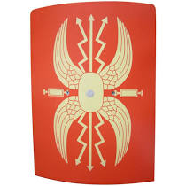
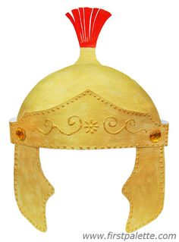
Creative Homework linked to
our theme on The Romans – Autumn Term 1

Each term, we will set a creative homework task linked to Year 4’s current topic. This term, the children have discussed and suggested their own ideas, with great excitement and enthusiasm! Their fabulous ideas are listed below. At home, they will design and make one of the following and bring their completed projects into school, on or after Wednesday 14^{th,} ready to share with the class the following week (from Monday 19th October).

- Design and make an item of Roman armour or weaponry such as a helmet, shield, sword, or bow and arrow.
- Design and make a Roman fort or an amphitheatre.
- Design and make a Roman boat or chariot.
- Make a miniature model of Hadrian’s Wall.
(Please note that the children only need to make one of the above!)

Creative homework is designed to excite and inspire children to become independent learners. There is no right way to do this task; every child’s creation will be unique, depending on how they choose to complete it. During their opportunity to share their designs and models, they will be expected to explain their choices of materials and how they created their final model.

Thank you for your support. Please contact me via the office should you have any questions and I will be happy to help

Mrs Blomeley

