Cat
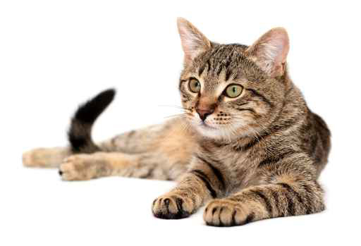
Height | 30cm
Length | 50cm
Weight | 5kg
Age | 15
Special Fact | 5  There are over 500 million domestic cats in the world.
Cow
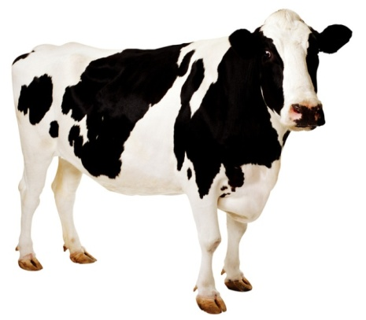
Height | 120cm
Length | 310cm
Weight | 800kg
Age | 25
Special Fact | 5  They sleep while standing up.

Crab
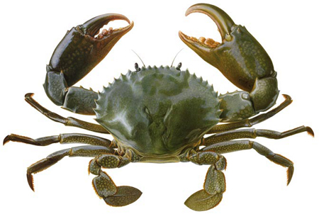
Height | 6cm
Length | 15cm
Weight | 0.5kg
Age | 2
Special Fact | 7  They have teeth in their stomach.
Ant
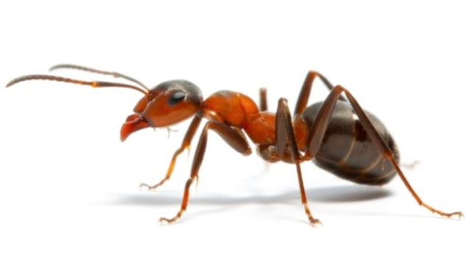
Height | 0.5cm
Length | 1cm
Weight | 0.00005kg
Age | 4 months
Special Fact | 10  They can lift and carry more than three times their own weight.

Bat
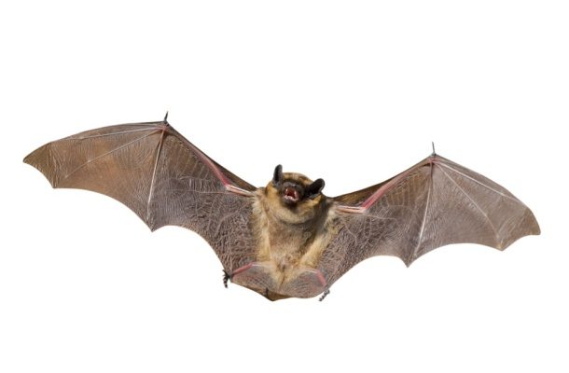
Height | 8cm
Length | 10cm
Weight | 0.1kg
Age | 8
Special Fact | 8  They are the only mammals that can fly.
Dog
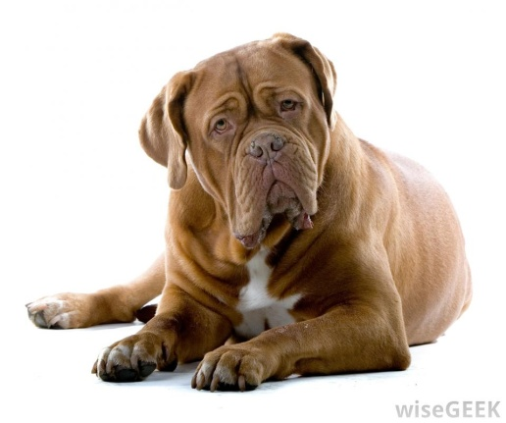
Height | 50cm
Length | 90cm
Weight | 22kg
Age | 15
Special Fact | 5  They have superior hearing to humans.

Duck
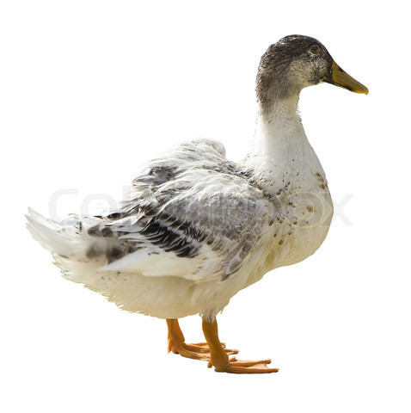
Height | 50cm
Length | 40cm
Weight | 4kg
Age | 10
Special Fact | 7  Most males ducks are silent.
Elephant
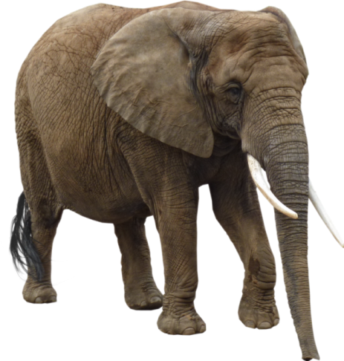
Height | 370cm
Length | 550cm
Weight | 5000kg
Age | 60
Special Fact | 8  They are the largest land animals in the world.

Frog
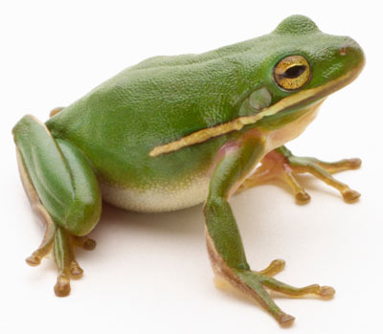
Height | 4cm
Length | 7cm
Weight | 0.2kg
Age | 5
Special Fact | 7  There are 4700 species of frog in the world.
Fox
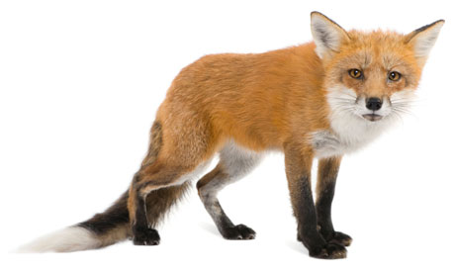
Height | 40cm
Length | 70cm
Weight | 6kg
Age | 3
Special Fact | 6  They can retract their claws, like cats.

Fly
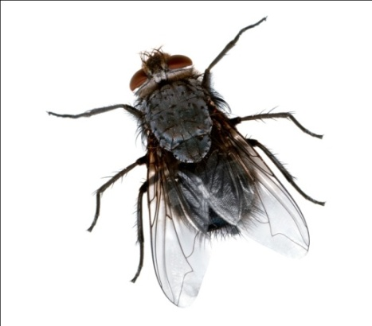
Height | 1cm
Length | 1cm
Weight | 0.00005kg
Age | 2 weeks
Special Fact | 8  Their wings beat up to 200 times a second.

Horse
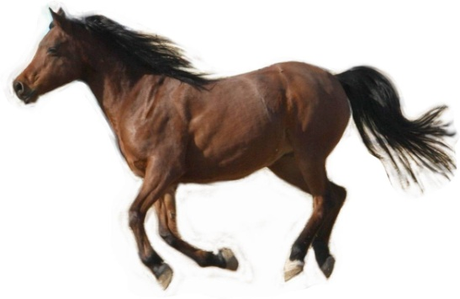
Height | 190cm
Length | 230cm
Weight | 600kg
Age | 25
Special Fact | 6  They can sleep standing up.

Caterpillar
Height | 1cm
Length | 5cm
Weight | 0.0005kg
Age | 3 weeks
Special Fact | 10  They have up to 4,000 muscles in their bodies.
Lion
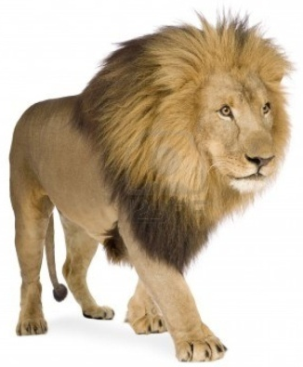
Height | 110cm
Length | 200cm
Weight | 150kg
Age | 12
Special Fact | 6  They are the only cats that live in groups, which are called prides.

Great White Shark
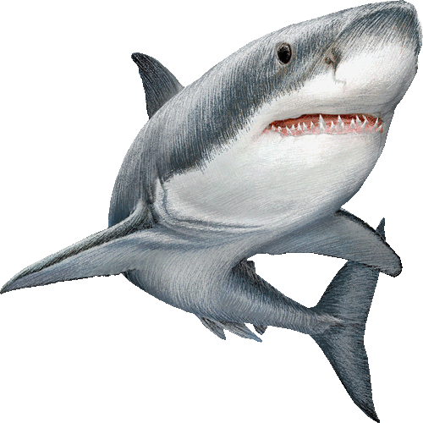
Height | 100cm
Length | 500cm
Weight | 2500
Age | 30
Special Fact | 7  They have up to 300 teeth.

Kangaroo
Height | 160cm
Length | 150cm
Weight | 80kg
Age | 6
Special Fact | 8  They can jump up to 3 times their own height.

Turtle
Height | 20cm
Length | 40cm
Weight | 8kg
Age | 40
Special Fact | 7  They have existed for 215 million years.
Octopus
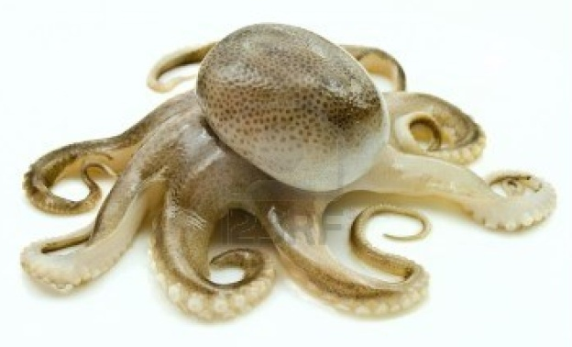
Height | 60cm
Length | 120cm
Weight | 7kg
Age | 1
Special Fact | 8  They can lose an arm to escape a predator's grasp and re-grow it later.

Tiger
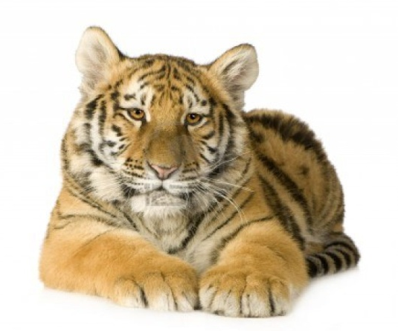
Height | 100cm
Length | 270cm
Weight | 170kg
Age | 9
Special Fact | 8  They can easily jump over 5 m in length

Brown Bear
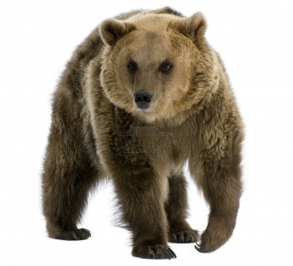
Height | 160cm
Length | 210cm
Weight | 300kg
Age | 25
Special Fact | 8  They can eat as much as 40 kg of food each day

Panda
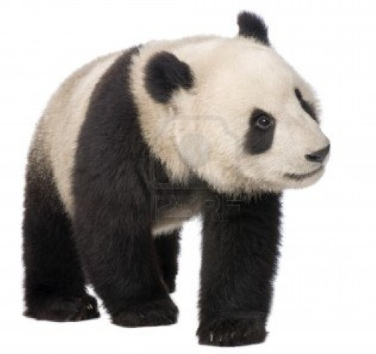
Height | 105cm
Length | 140cm
Weight | 120kg
Age | 20
Special Fact | 7  They eat bamboo for up to 12 hours every day.
Snake
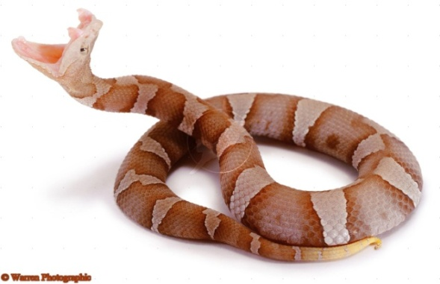
Height | 6cm
Length | 90cm
Weight | 5kg
Age | 15
Special Fact | 8  Some are poisonous, some are harmless.

Dolphin
Height | 60cm
Length | 250cm
Weight | 250kg
Age | 40
Special Fact | 9  Only half their brains go to sleep, the other half stays awake.

Zebra
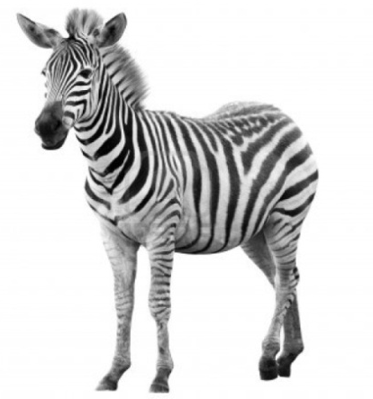
Height | 170cm
Length | 200cm
Weight | 300kg
Age | 25
Special Fact | 6  Their stripes are as unique as fingerprints, no two are exactly alike.

Penguin
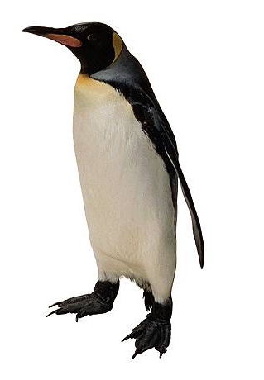
Height | 120cm
Length | 30cm
Weight | 32kg
Age | 20
Special Fact | 8  Males balance the egg on their feet for two months with no food.

Wolf
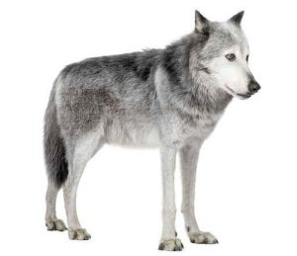
Height | 90cm
Length | 180cm
Weight | 40kg
Age | 7
Special Fact | 7  They live and hunt in packs of around six to ten animals.

Squirrel
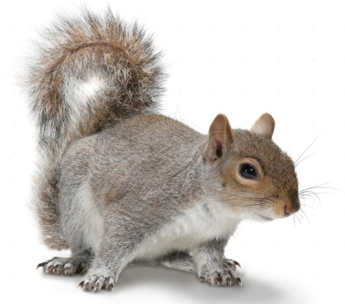
Height | 20cm
Length | 35cm
Weight | 1kg
Age | 12
Special Fact | 5  They have 4 front teeth that never stop growing
Crocodile
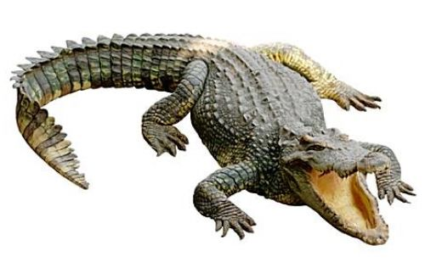
Height | 50cm
Length | 450cm
Weight | 500kg
Age | 60
Special Fact | 9  They have the strongest bite of any animal.

Skunk
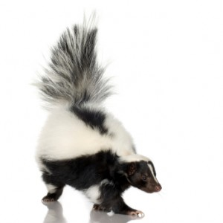
Height | 30cm
Length | 50cm
Weight | 3kg
Age | 3
Special Fact | 6  They can spray their smelly scent up to 3m
Pig
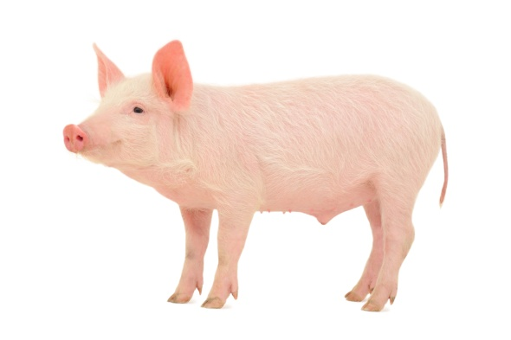
Height | 70cm
Length | 150cm
Weight | 250kg
Age | 27
Special Fact | 6  They are unable to sweat.

Hyena
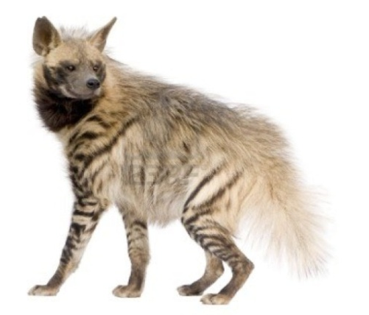
Height | 85cm
Length | 150cm
Weight | 70kg
Age | 20
Special Fact | 8  They live in groups of up to 80
Sheep
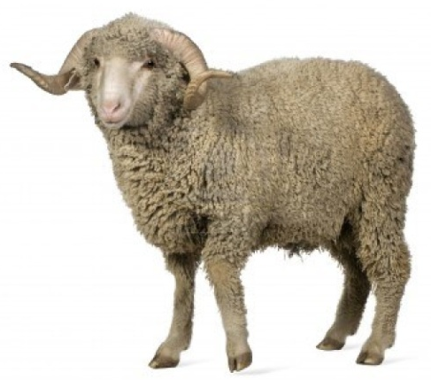
Height | 85cm
Length | 190cm
Weight | 130kg
Age | 10
Special Fact | 7  They have 4 stomachs to help digest food.

Ostrich
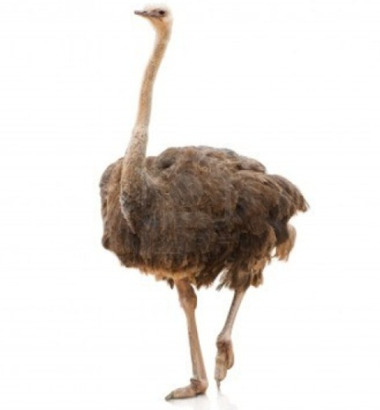
Height | 250cm
Length | 100cm
Weight | 115kg
Age | 35
Special Fact | 6  The ostrich has the largest eye of any land animal, at 5 cm across.

Flamingo
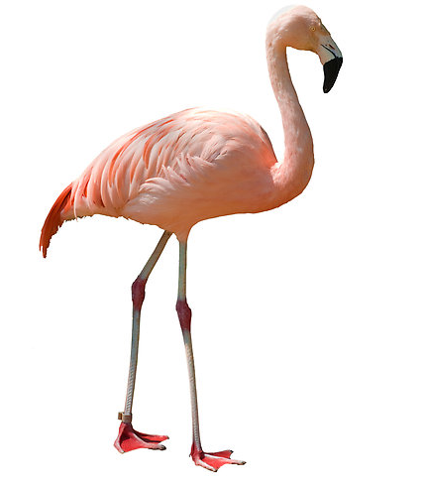
Height | 120cm
Length | 50cm
Weight | 4kg
Age | 40
Special Fact | 6  They are born gray and white and do not turn pink for two years

Hippo
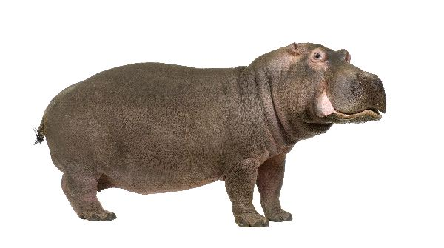
Height | 170cm
Length | 350cm
Weight | 3000kg
Age | 40
Special Fact | 6  They spend 16 hours a day in water.
Rhino
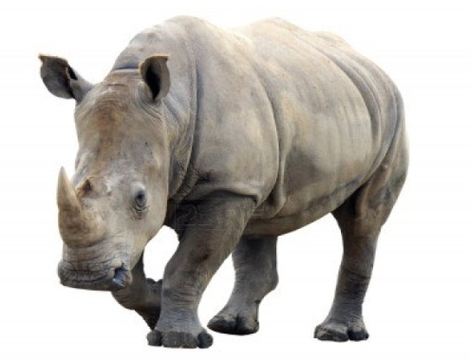
Height | 180cm
Length | 360cm
Weight | 2700kg
Age | 50
Special Fact | 7  Their horns are made from the same substance that human hair is.

