How animals adapt to their environment
Polar bears
Animals of the Arctic have many adaptations to help them survive in often inhospitable climate. A polar bear lives in the cold, snowy Arctic lands. They are the largest land carnivores (which mean they eat meat).
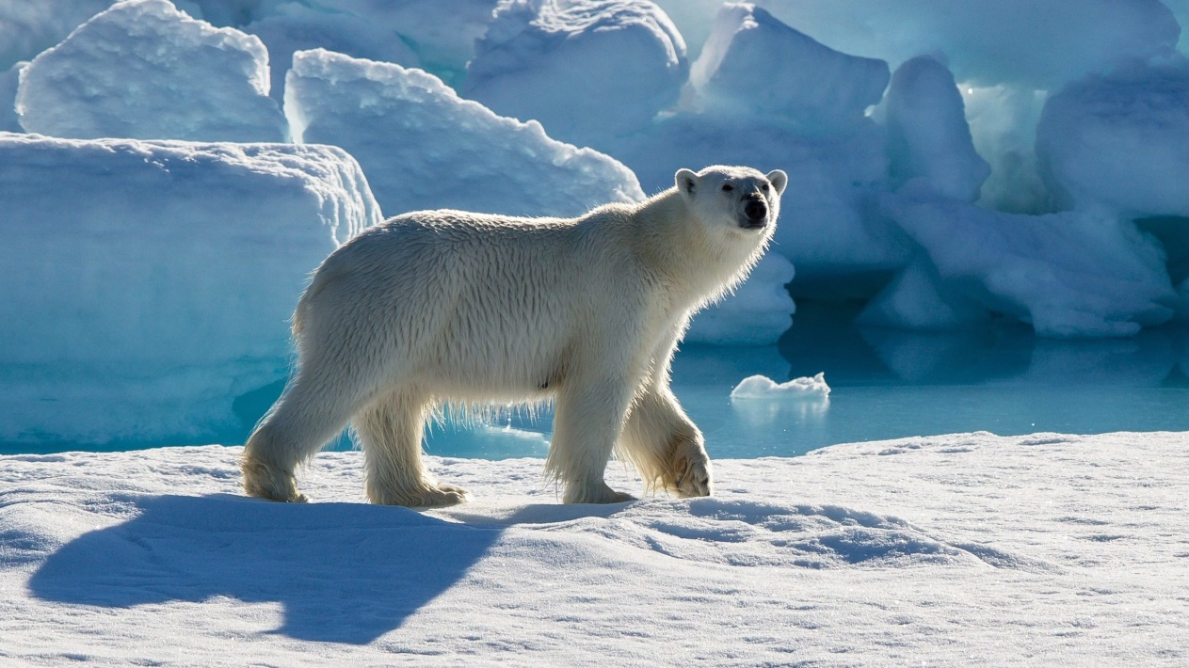
How has a polar bear adapted to its Arctic environment?
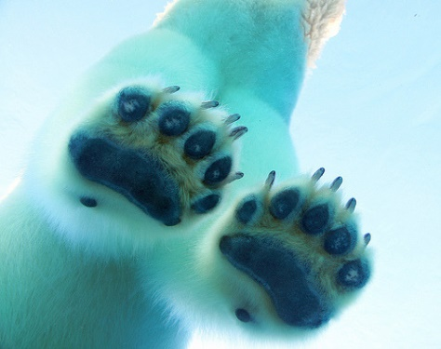
- Their white fur helps them blend in with the snow and ice.
- A polar bear has a layer of fat under its skin which helps it stay warm. It also has a thick layer of fur.
- The wide, large paws help a polar bear to walk in the snow.
- When a polar bear swims under water it closes it nostrils so no water can get in.
Polar bears paws on the ice
Why will we not find a polar bear living in a desert?
Polar bears are adapted to suit a cold environment.

Penguins
Some Penguins live in the Antarctic, where it is extremely cold, and the water temperatures never rise above freezing. Others live further North, but all penguins live in the Southern Hemisphere. Penguins are flightless birds, but are excellent swimmers. They live on pack ice and in the oceans around Antarctica. They breed on the land or ice surfaces along the coast and on islands.
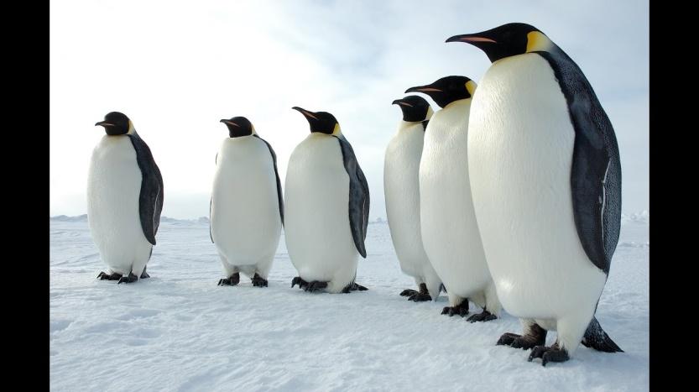
How has a penguins adapted to its Arctic environment?
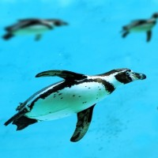
- Penguins have webbed feet for powerful swimming. Their bodies are streamlined to reduce drag in water. Their wings, shaped like flippers, which also helps them "fly" underwater at speeds up to 15 mph.
- Penguins have to keep high body temperatures to remain active. They have thick skin and lots of fat (blubber) under their skin to keep warm in cold weather.
- They also huddle together with their friends to keep warm. Emperor penguins have developed a social behaviour that when it gets cold, they huddle together in groups that may comprise several thousand penguins.
Penguins using their wings to swim
- The dark coloured feathers of a penguin's back surface absorb heat from the sun, helping them to warm up too.
- Penguins tightly packed feathers overlap to provide waterproofing and warmth. They coat their feathers with oil from a gland near the tail to increase impermeability. Waterproofing is critical to penguins' survival in water, Antarctic seas may be as cold as -2.2°C and rarely get above +2°C, (-2°C is the freezing point of sea water, below zero because of the salt).
- Penguins don't have all the extra airspaces in their bones that normal birds have. Their heavy, solid bones act like a diver's weight belt, allowing them to stay underwater.

