2.6 miles for charity!
#TwoPointSixChallenge

Hello my name is Henry and I am 8 years from Dukinfield I have been doing a 2.6 mile run for charity. We are raising money for willow wood hospice. We came up with the idea when I asked my mum when would the bubble rush be on. She told me it might not be on because of the coronavirus. I said to her “we could raise money for charity” and the bubble rush is raising money for willow wood so I asked her if we could do it for willow wood she said yes.

I have decided to keep this diary so I can remember where I ran each day.

DAY 1
Date: 23rd April 2020
Time: 39 minutes 7 seconds
Today we ran over to gorse hall and into Stalybridge. On the run we stopped and found out we were at willow wood shop!!! Then we bumped into my cousin Lucy we waved from a distance then started running again down the canal.

DAY 2
Date: 24th April 2020
Time: 33 minutes 18 seconds
Today we went running over the golf course. I enjoyed it more today than the first day. It was fun and we even beat the time of the first day!!! The Tameside Reporter wrote an article about me and put it on Their facebook page.

DAY 3
Date: 25th April 2020
Time: 28 minutes 05 seconds
Today was the third day and I ran around Dukinfield finishing at my Grandma’s. She gave me a capri sun and a wispa chocolate bar and waved to me from the window. Then we walked back home. I’m looking forward to the next day.

DAY 4
Date: 26th April 2020
Time: 34 minutes 41 seconds
Today we ran in the shape of a W for willow wood and it was epic except the end where my mum made me go up Quarry Rise! Luckily we didn’t have to run all the way up because we finished the 2.6 miles near the bottom but I still had to walk so I wasn’t happy! I was inspired today as my Uncle Chris got up at 3:30 in the morning and ran a whole marathon. He was raising money too for another charity and raised over £1000.
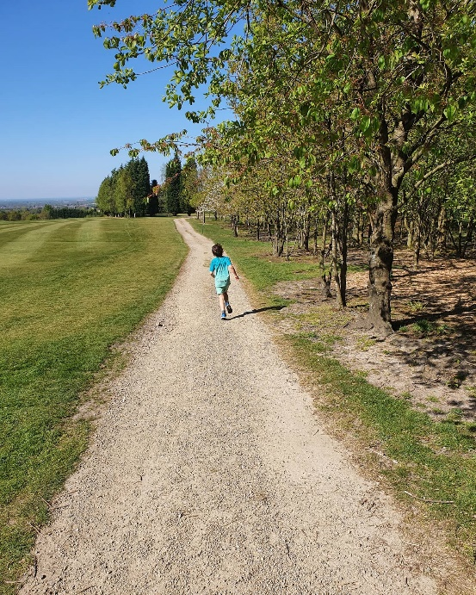
DAY 5
Date: 27th April 2020
Time: 32 minutes 12 seconds
Today we ran across the golf course It was really good we saw one of my friends from school (Abigail) and coming back we saw another one of my friends in the car coming home! It was nice to see my friends as I haven’t seen them in so long. The famous comedian Justin Moorhouse retweeted my just giving link.
DAY 6
Date: 28th April 2020
Time: 31 minutes 59 seconds
Today we ran to Hyde and saw my grandpa at work and then ran and saw my grandma at her house. We waved to her and she shouted well done! It was raining today and a bit colder but I kept warm by keeping on running.
DAY 7
Date: 29th April 2020
Time: 35 minutes 25 seconds
Today we ran across the golf course then we came of the back lanes and on to gorse hall then did a lap of gorse hall came of it and went back on the golf course, came of the fairways and back home. I didn’t like this route as we didn’t plan it and it seemed to take a long time to finish. My legs were really tired today.
DAY 8
Date: 30th April 2020
Time: 36 minutes 41 seconds
Today we went on the golf course AGAIN but I actually really enjoyed it because it is my favourite route. Some people that we ran by said “well done” and “keep going” to me and that was nice. This is my favourite route because it’s quite peaceful. Today, The Reporter printed the story in the newspaper my mum got five copies!!! Jonathan Reynolds who is our local MP also wrote to me about my fundraising and put my Just Giving link on his Facebook page. He also sponsored me £10. Today was a good day as we managed to get over £1000!!

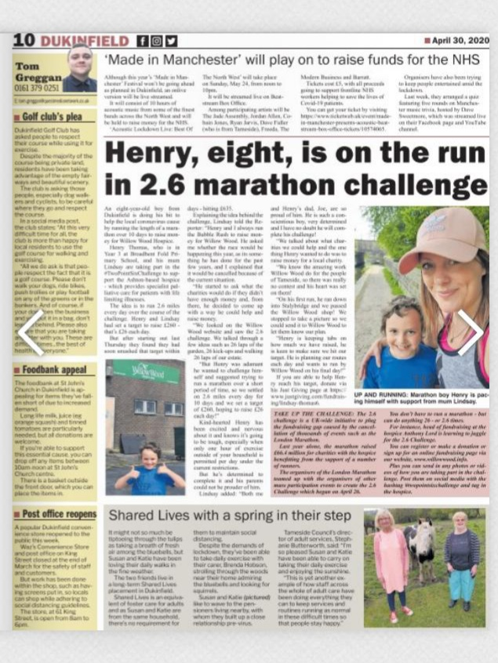
DAY 9
Date: 1st May 2020
Time: 35 minutes 9 seconds
We ran around Dukinfield. Today I found it tough as my legs were really tired. But then afterwards it was AMAZING because after the run we went in my grandma’s garden (we did socially distance) and she gave me an ice lolly to cool down! Today we got a £50 donation from someone at my dad’s work. It came in the post I was really happy and really surprised.
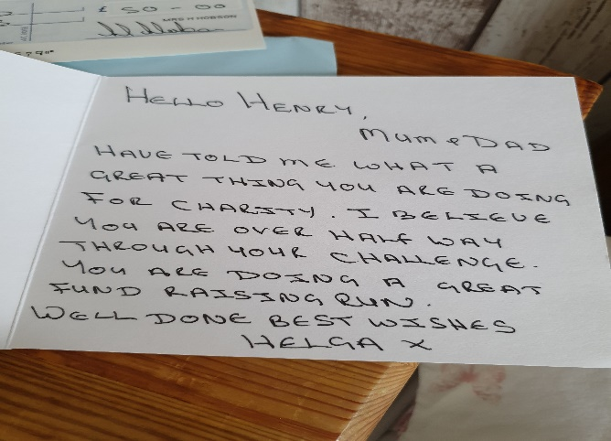
DAY 10
Date:2nd May 2020
Time: 30 minutes 46 seconds
Today we ran my favourite route AROUND THE GOLF COURSE AGAIN it was really good. It was tough because the last part was all uphill. As a treat I also got to watch a movie and have a nice dinner the day was EPIC.
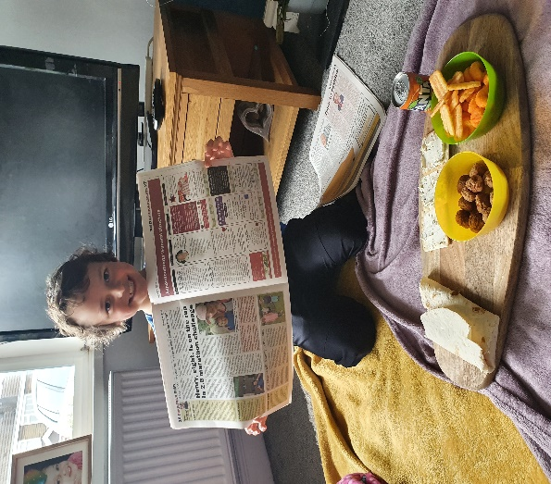

RESULTS
I used Excel to make graphs out of my times and the money that I raised each day. Here are my results.

My fastest time was on day 3 and my slowest time was on day 1.

I can’t believe how much money I have raised for Willow Wood. Even though I stopped running on day 10 people still donated to me and the amount carried on going up.

